

CAPSTONE PROJECT REPORT
Report 6 – Software User Guides

– Hanoi, Jan 2025 –
Table of Contents
I. Record of Changes 3
II. Release Package & User Guides 4
1. Deliverable Package 4
2. Installation Guides 5
2.1 System Requirements 5
2.2 Installation Instruction 6
3. User Manual 10
3.1 Overview 10
3.2 Authentication 11
3.3 Student 13
3.4 Teacher 20
3.5 Expert 34
3.6 Admin 37
3.7 Manager 45

I. Record of Changes
Date | A*  M, D | In charge | Change Description
09/04/2026 | A | LinhVTK | Add Deliverable Package
12/04/2026 | A | TuNC | Add Installation Guides
13/04/2026 | A | TuNC, DatMN  LinhVTK | Add User Manual
*A - Added M - Modified D - Deleted

II. Release Package & User Guides

1. Deliverable Package
No. | Deliverable Item | Description
1 | Project Introduction | Presents the project context, including its purpose, goals, scope, assumptions, limitations, and main stakeholders involved.
2 | Project Management Plan | Defines how the project is planned and managed, covering timeline, scope, resources, risks, communication approach, quality assurance, and execution strategy.
3 | Project Tracking | Provides tools or reports used to monitor project progress, task allocation, resource usage, milestones, and comparison between planned and actual results.
4 | Software Requirement Specification | Describes in detail all system requirements, including functional and non-functional aspects, business rules, constraints, and supporting diagrams.
5 | Software Design Document | Explains the system design at both high-level and detailed levels, including architecture, database structure, and key design diagrams.
6 | Test Documentation | Includes testing plans and materials such as test strategy, scenarios, and detailed test cases for validating the system.
7 | Unit Test | Verifies individual components or functions to ensure each module works correctly in isolation.
8 | Integration Test | Validates the interaction between integrated modules, ensuring correct data flow and system communication.
9 | System Test | Tests the complete system to ensure it meets all requirements, including functionality, performance, security, and usability.
10 | User Acceptance Test | Confirms with end-users that the system satisfies business needs and is ready for release.
11 | Software User Guides | Provides instructions for users on how to operate the system, navigate features, and resolve common issues.
12 | Final Project Report | Summarizes project outcomes, evaluates performance, compares planned vs. actual results, and highlights lessons learned with recommendations.
13 | Source Codes | Contains the full system source code, organized and documented for maintenance, build, and deployment.
14 | Database Script | Includes all database-related scripts such as schema creation, tables, procedures, triggers, and data setup.
15 | Slide | Summarizes the project in presentation form, highlighting objectives, approach, key features, results, and future improvements.

2. Installation Guides

2.1 System Requirements

2.1.1 Software Requirements
Component | Minimum Version | Recommended Version | Notes
Java (JDK) | JDK17 | JDK17 LTS | Required. Backend runtime.
Maven | 3.6+ | 3.9+ | Build tool. Bundled via mvnw.
Git | v2.30+ | v2.40+ | Required to clone and manage the repository.
MySQL | v8.0+ | MySQL 8.0+ | Primary database used by the system.

2.1.2 Installation Instruction
Service | Purpose | Required
Cloudinary Account | Media and asset storage | Required
Groq API Key | AI (LLaMA + Whisper) | Required
Mapbox API Key | Map and geolocation (Frontend) | Required
PayOS Account | Payment processing | Required
Google OAuth2 | Social login (Google) | Optional

2.2 Installation Instruction

2.2.1 Environment Preparation
Step 1: Install MySQL
- Download MySQL Community Server: https://dev.mysql.com/downloads/mysql/
- Install using default options.
- Start the MySQL service via the Services Manager.
- Verify installation:
mysql --version # Expected: mysql 8.0.x
Step 2: Install Java (JDK 17+)
- Download JDK 17 LTS: https://adoptium.net/
- Run the installer and follow on-screen instructions.
- Set environment variables:
JAVA_HOME` = `C:\Program Files\Eclipse Adoptium\jdk-17.x.x`
- Add `bin` to `PATH`
- Verify installation:
java --version # Expected: openjdk 17.x.x
javac --version # Expected: javac 17.x.x
Step 3: Install Maven
- Download Maven: https://maven.apache.org/download.cgi
- Extract to `C:\Program Files\Apache\Maven`
- Add `bin` folder to `PATH`
- Verify installation:
mvn --version # Expected: Apache Maven 3.9.x
Step 4: Install Git
- Download Git: https://git-scm.com/download/win
- Run the installer (use default options).
- Verify installation:
git --version # Expected: git 2.40+

2.2.2 Clone the Project
Step 1: Download code from GitHub
git clone https://github.com/giangkh1908/NovaLMS.git
Step 2: Access folder
cd NovaLMS
Step 3: Navigate to project directory
cd DoAn
Step 4: Verify project structure
Ls # You will see: pom.xml, src/, mvnw, …\

2.2.3 Backend Install
Step 1: Backend Installation
cd ISP490_G1_NovaLMS
cd NovaLMS
cd DoAn
mvnw.cmd clean install
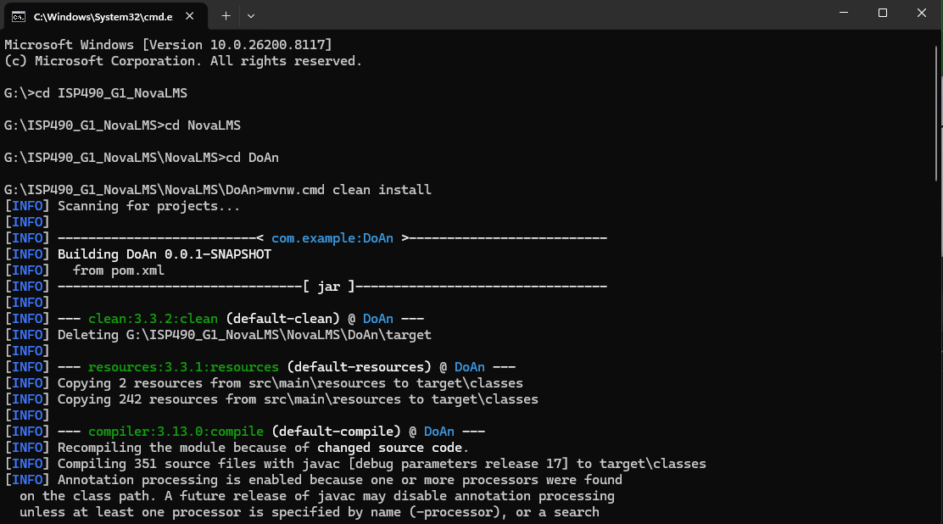

Step 2: Create MySQL database
```properties
# Database
spring.datasource.url=jdbc:mysql://localhost:3306/nova_1?useSSL=false&serverTimezone=UTC&allowPublicKeyRetrieval=true
spring.datasource.username=root
spring.datasource.password=YOUR_PASSWORD
#JWT
app.jwt.secret=YOUR_32_CHARS_SECRET_KEY
app.jwt.expiration-ms=86400000
# Google OAuth2
spring.security.oauth2.client.registration.google.client-id=YOUR_GOOGLE_CLIENT_ID
spring.security.oauth2.client.registration.google.client-secret=YOUR_GOOGLE_CLIENT_SECRET
#Email SMTP
spring.mail.host=smtp.gmail.com
spring.mail.port=587
spring.mail.username=YOUR_EMAIL@gmail.com
spring.mail.password=YOUR_APP_PASSWORD
# Cloudinary
cloudinary.cloud-name=YOUR_CLOUD_NAME
cloudinary.api-key=YOUR_API_KEY
cloudinary.api-secret=YOUR_API_SECRET
# Groq AI
groq.api.url=https://api.groq.com/openai/v1
groq.api.key=YOUR_GROQ_API_KEY
groq.model=llama-3.3-70b-versatile
# PayOS
payos.client-id=YOUR_PAYOS_CLIENT_ID
payos.api-key=YOUR_PAYOS_API_KEY
payos.checksum-key=YOUR_PAYOS_CHECKSUM_KEY
payos.base-url=https://api-merchant.payos.vn
payos.frontend-url=http://localhost:8080
# File Upload
spring.servlet.multipart.max-file-size=25MB
spring.servlet.multipart.max-request-size=25MB
```
Step 4: Run the application
.\mvnw.cmd spring-boot:run
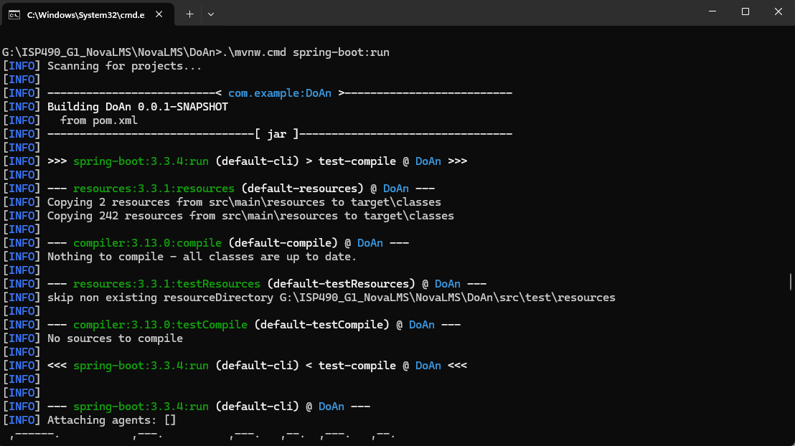

3. User Manual

3.1 Overview
NovaLMS (Nova Learning Management System) is a centralized, web-based learning management platform developed to streamline teaching operations and administrative efficiency for language learning centers. NovaLMS replaces fragmented manual processes with a unified platform for all stakeholders: administrators, managers, content experts, teachers, and students.
The system organizes its functionality around six core modules:

- User Management: Manages users and role-based access control across five roles (Admin, Manager, Expert, Teacher, Student), each granted distinct permissions tailored to their responsibilities.
- Course & Content Management: Content experts build structured course content organized into Modules and Lessons, supporting YouTube Video lessons and Document lessons with downloadable attachments.
- Quiz & Assignment Management: Creates, manages, and assigns assessments to students. Supports multiple question types, configurable time limits, passing scores, and both automated and manual grading with AI-assisted grading support.
- Class & Session Management: Manages class assignments, teacher allocations, and session scheduling. The system automatically sends email notifications for new sessions, reschedules, and cancellations. Supports a structured approval workflow for schedule change requests between teachers/students and managers.
- Payment & Registration: Integrates PayOS payment gateway for online course registration and payment processing. Automatically approves enrollments and sends PDF invoice receipts upon successful payment.
- Admin Dashboard & Analytics: Provides operational oversight through revenue charts, user statistics, course load analysis, enrollment trends, and Excel-based report exports.

3.2 Authentication

3.2.1 Sign up
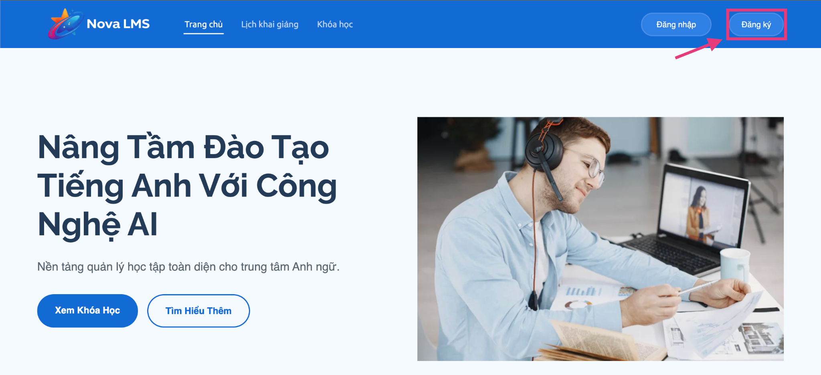
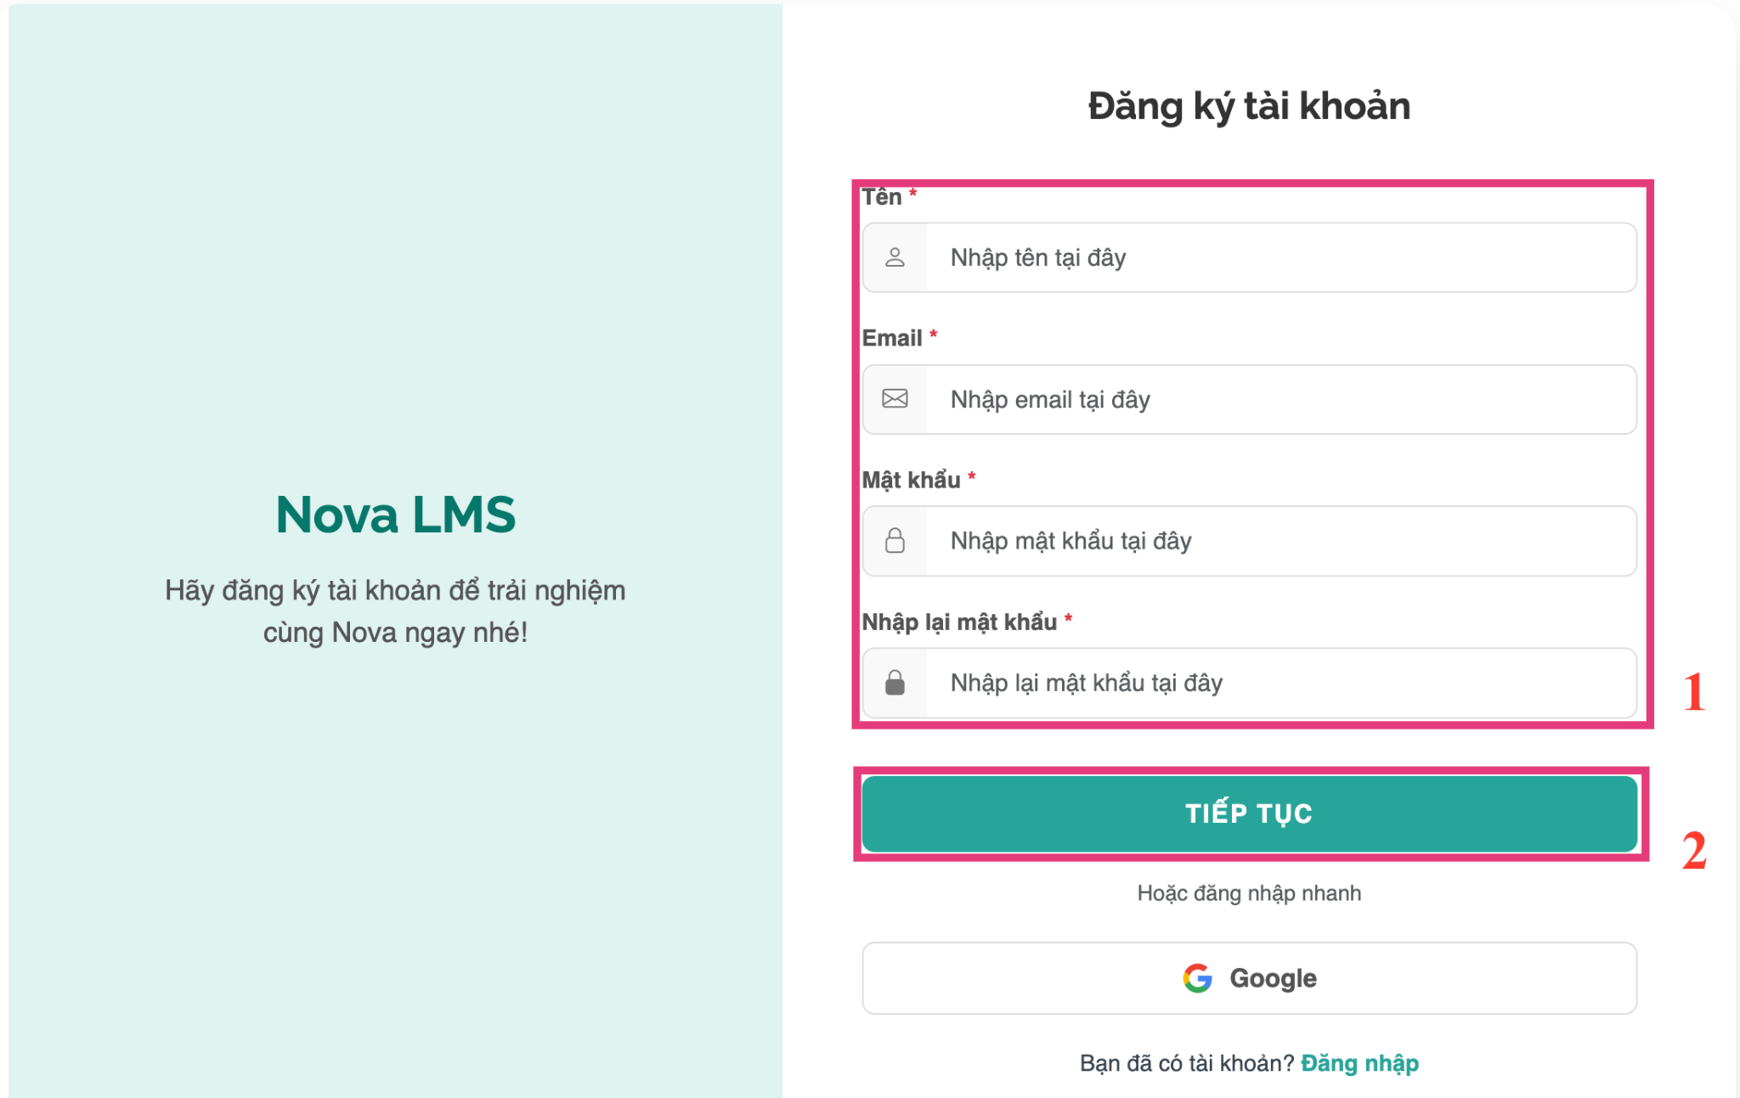
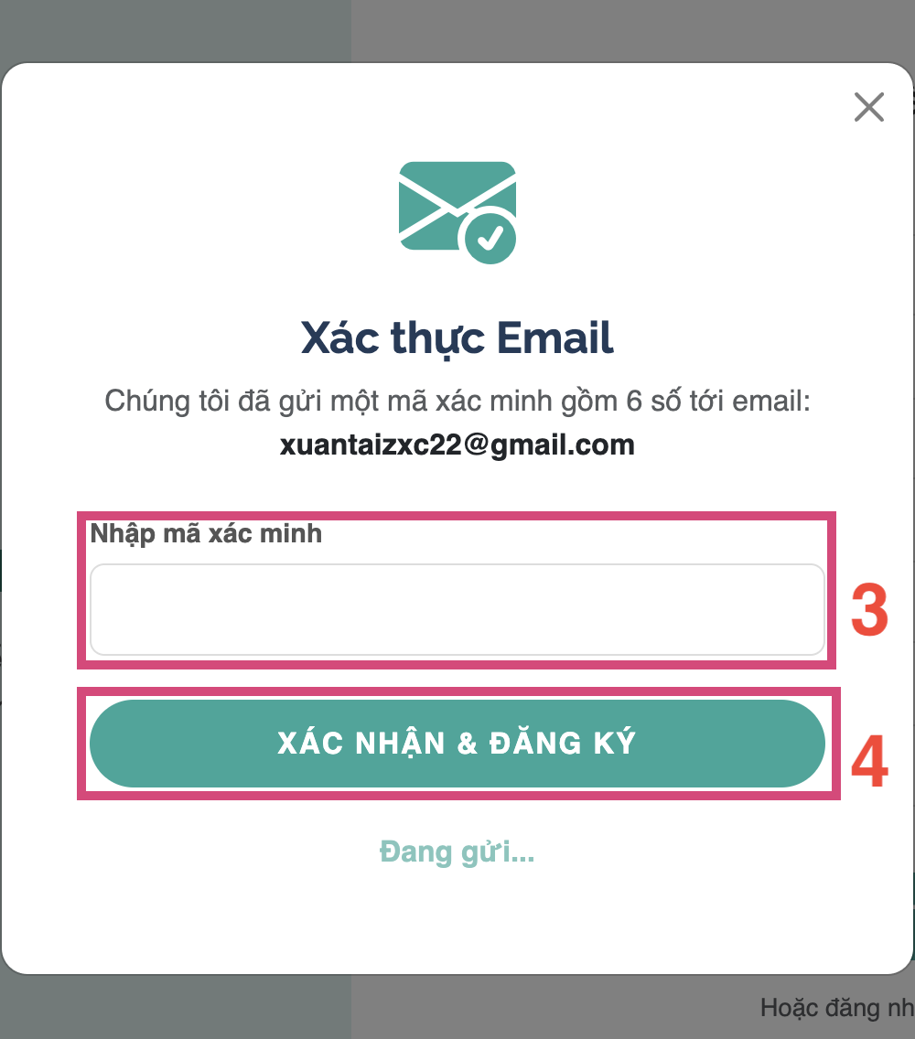
Openhttps: isp490-g1-novalms.onrender.com
Step 1: Click 'Register' on the login page
Step 2: Fill in all required fields:
- Full Name (Full Name)
- Email — must be a valid email address
- Password — enter your desired password
- Confirm Password — re-enter your password
- Step 3: Click 'Continue' (Continue).
Step 4: A verification modal appears. A 6-digit verification code will be sent to your email. Enter the code into the verification field.
Step 5: Click 'Confirm & Register' (Confirm & Register).
Step 6: Upon successful registration, you will be redirected to the login page. Use your email and password to sign in.

3.3 Student

3.3.1 Track Courses
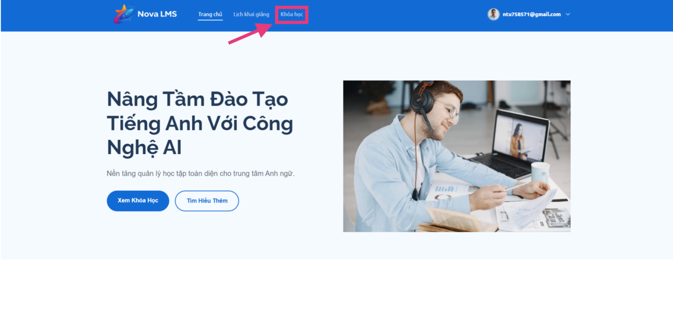
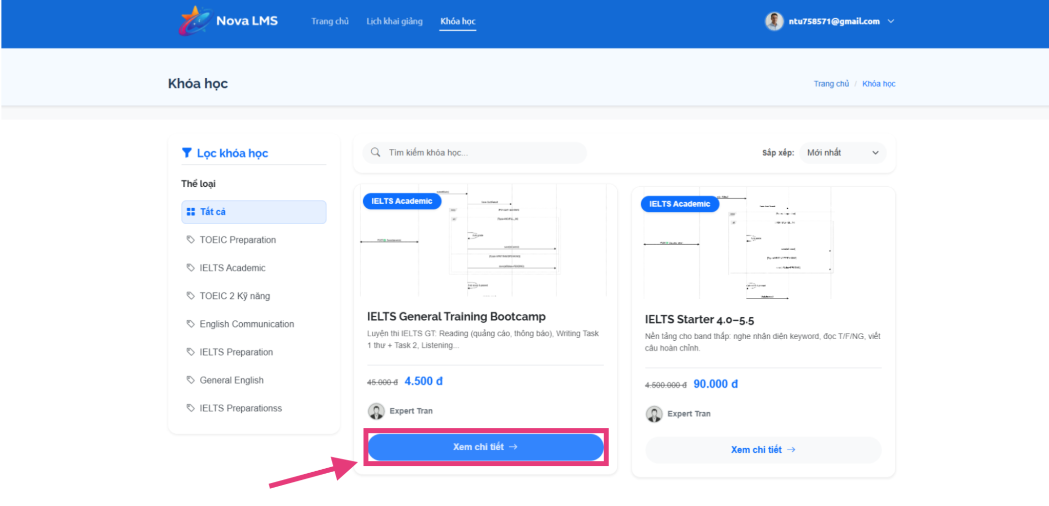
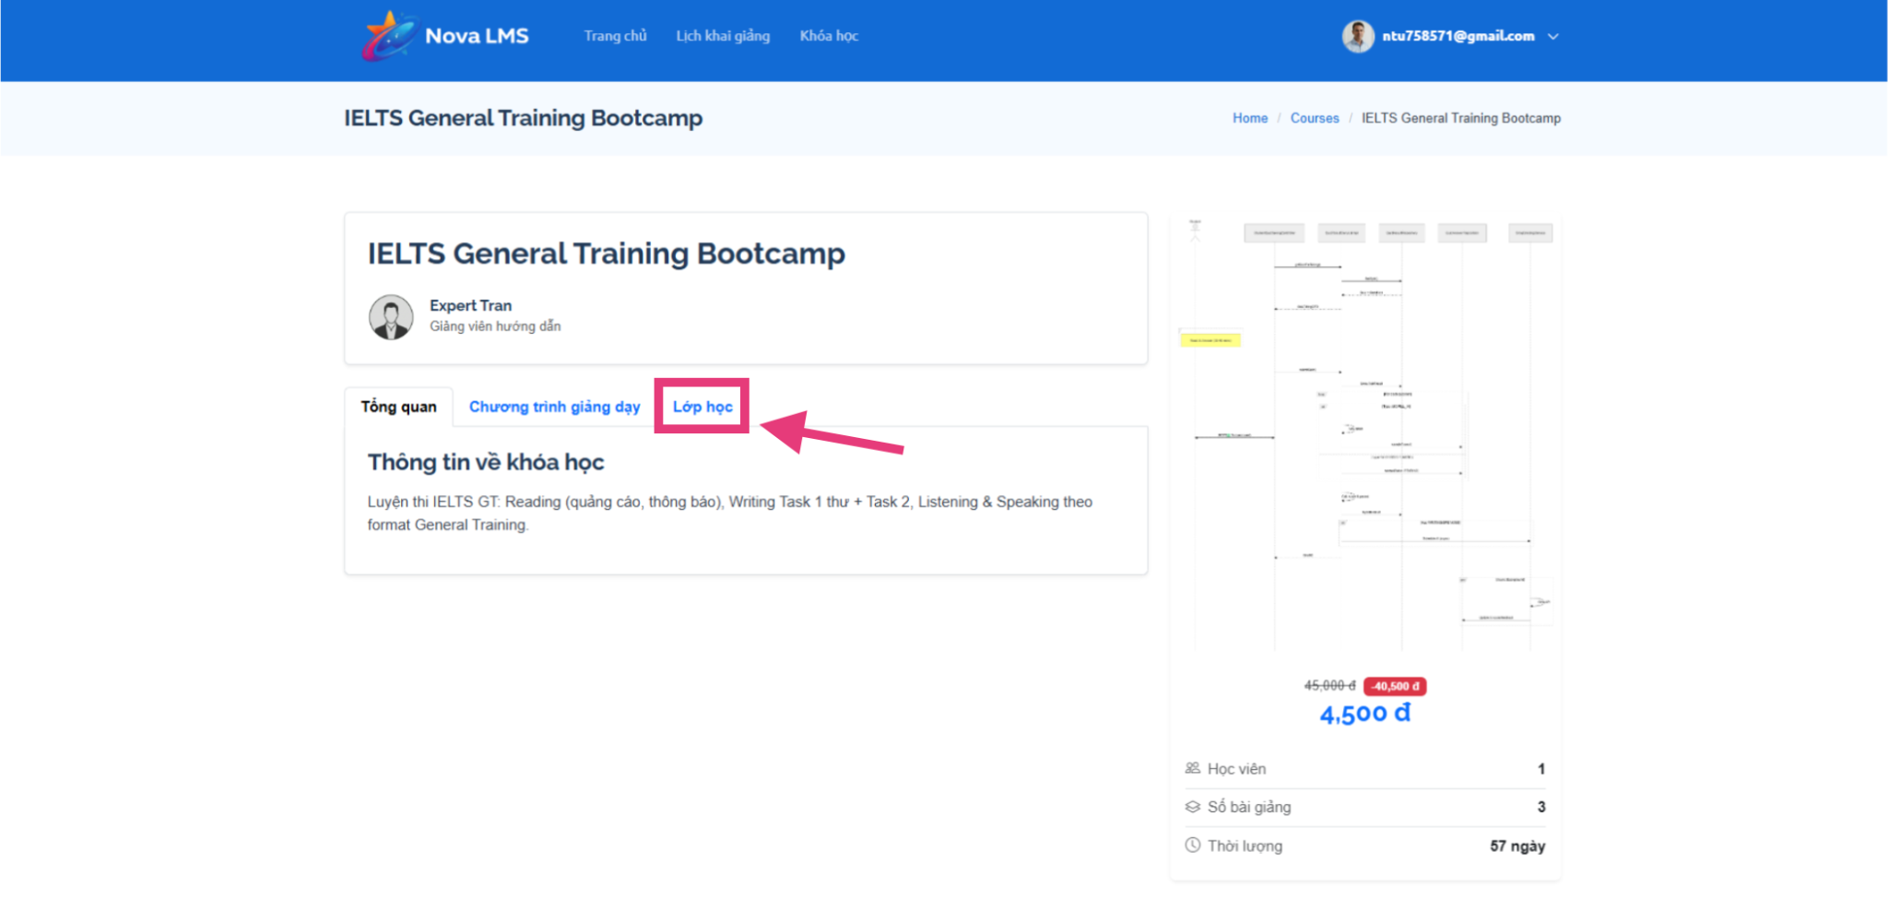
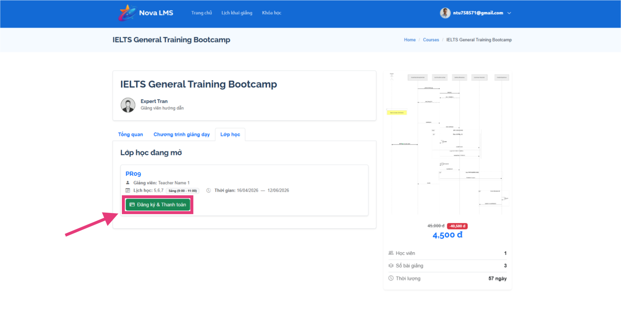
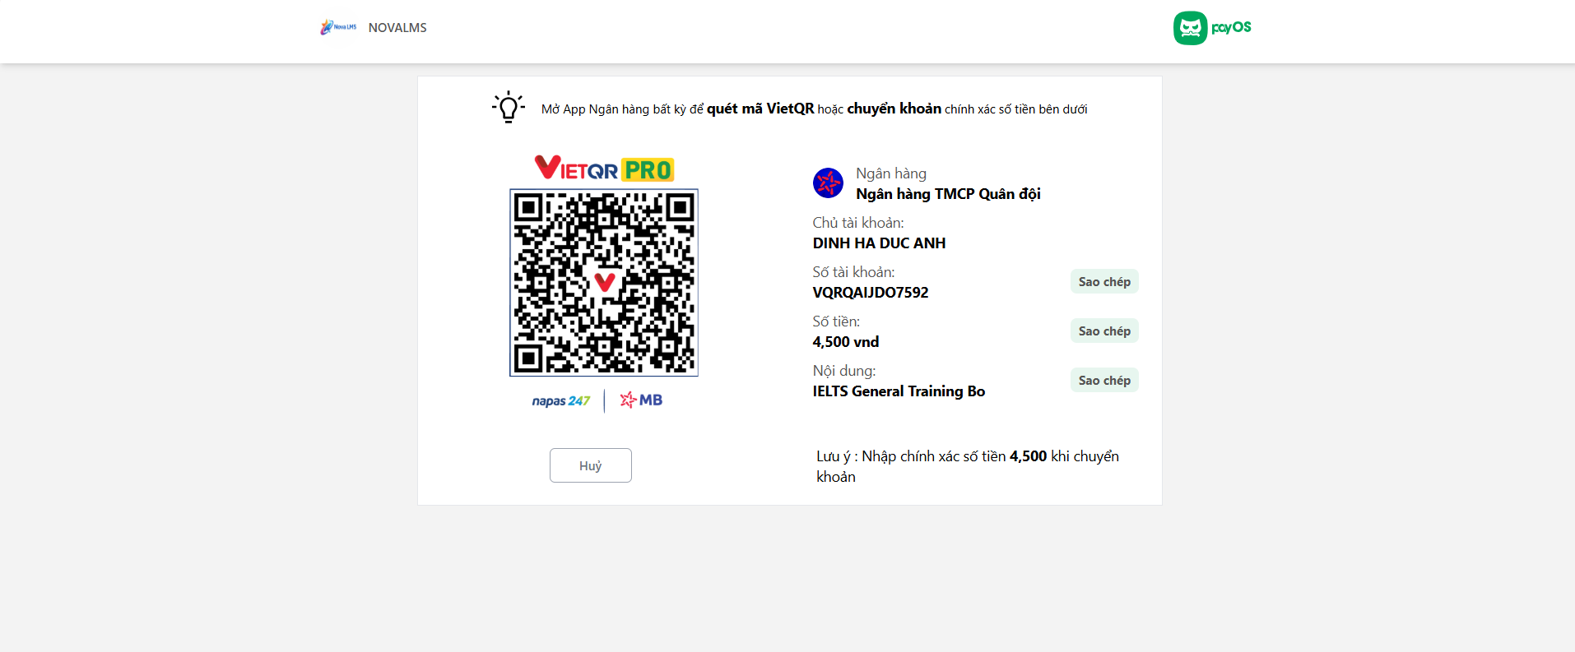
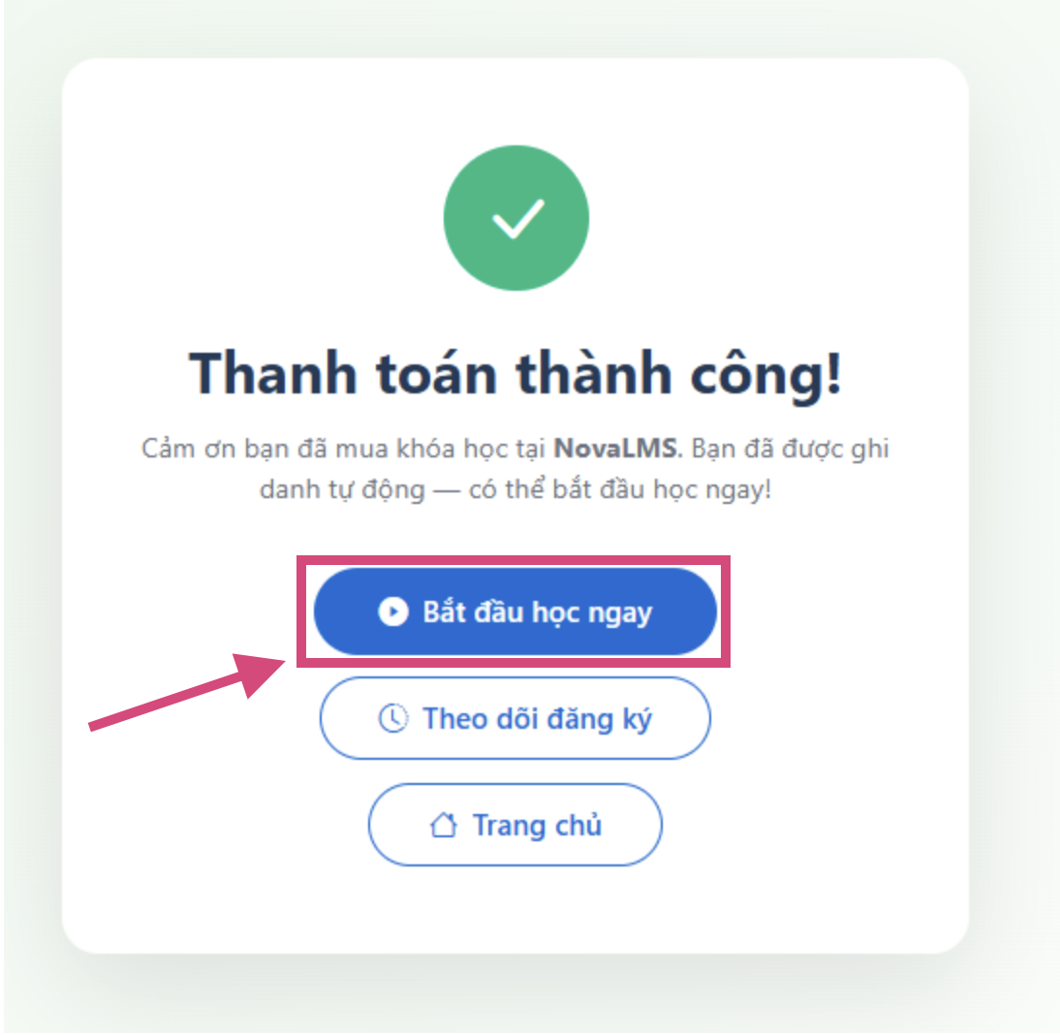
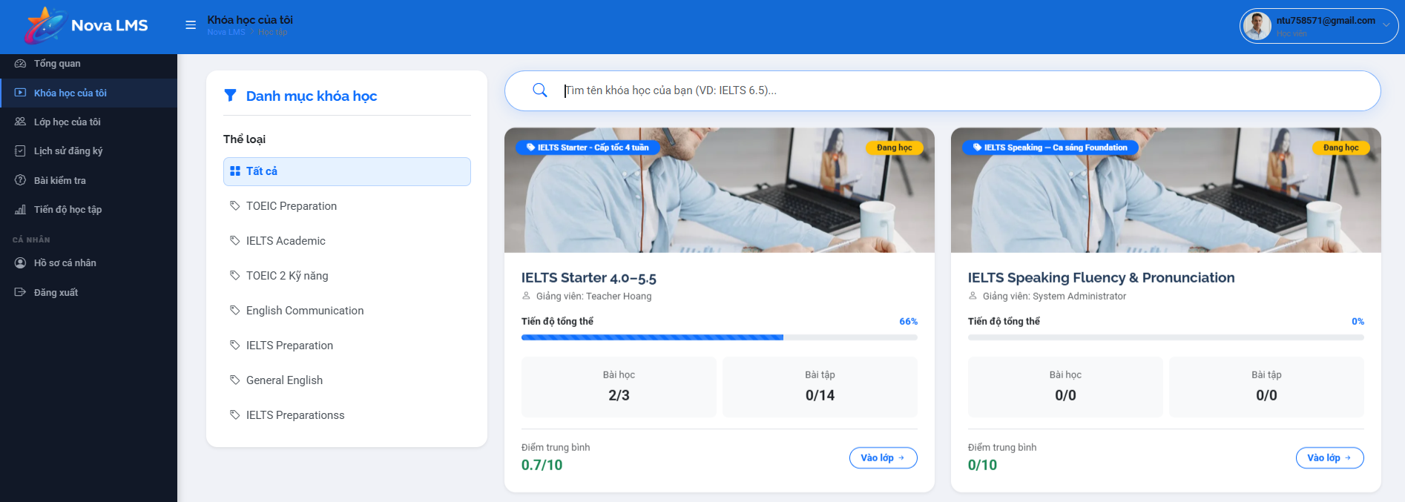
Step 1: Go to My Courses page.
Step 2: View all your enrolled courses with status:
- Approved — you can start learning
- Waiting for PayOS payment (Pending Payment) — payment not yet completed
- Paid — payment confirmed, waiting for approval
- Rejected — enrollment was rejected by Manager
Step 3: Click on a course card to enter the learning page. You can view the course structure including Modules, Lessons, and assigned Quizzes/Assignments.

3.3.1 View Finding Costs
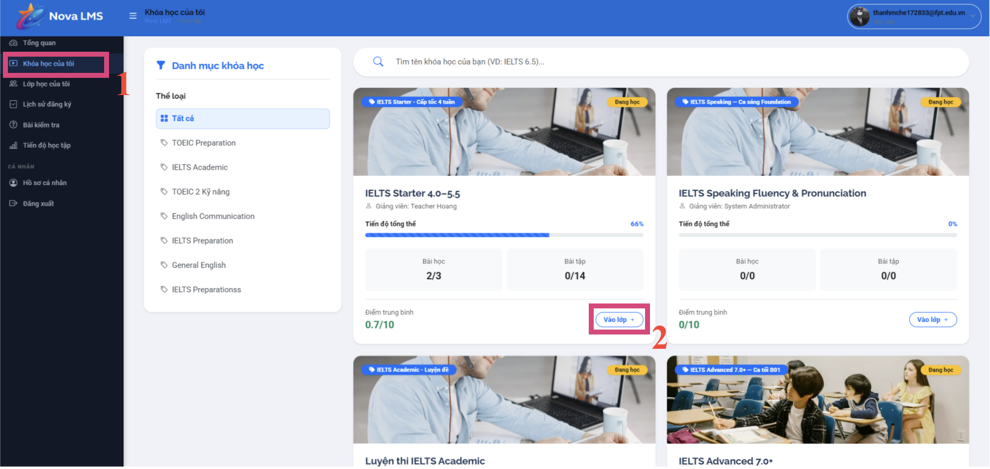
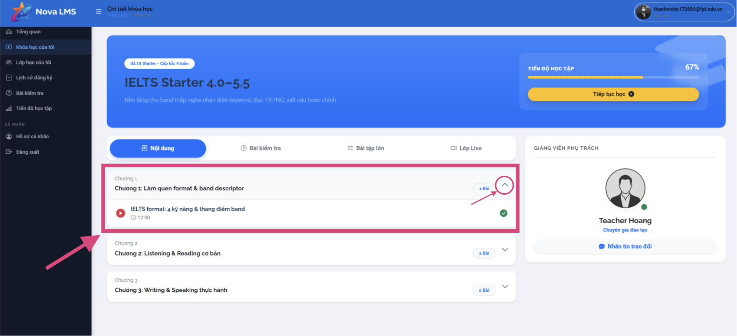
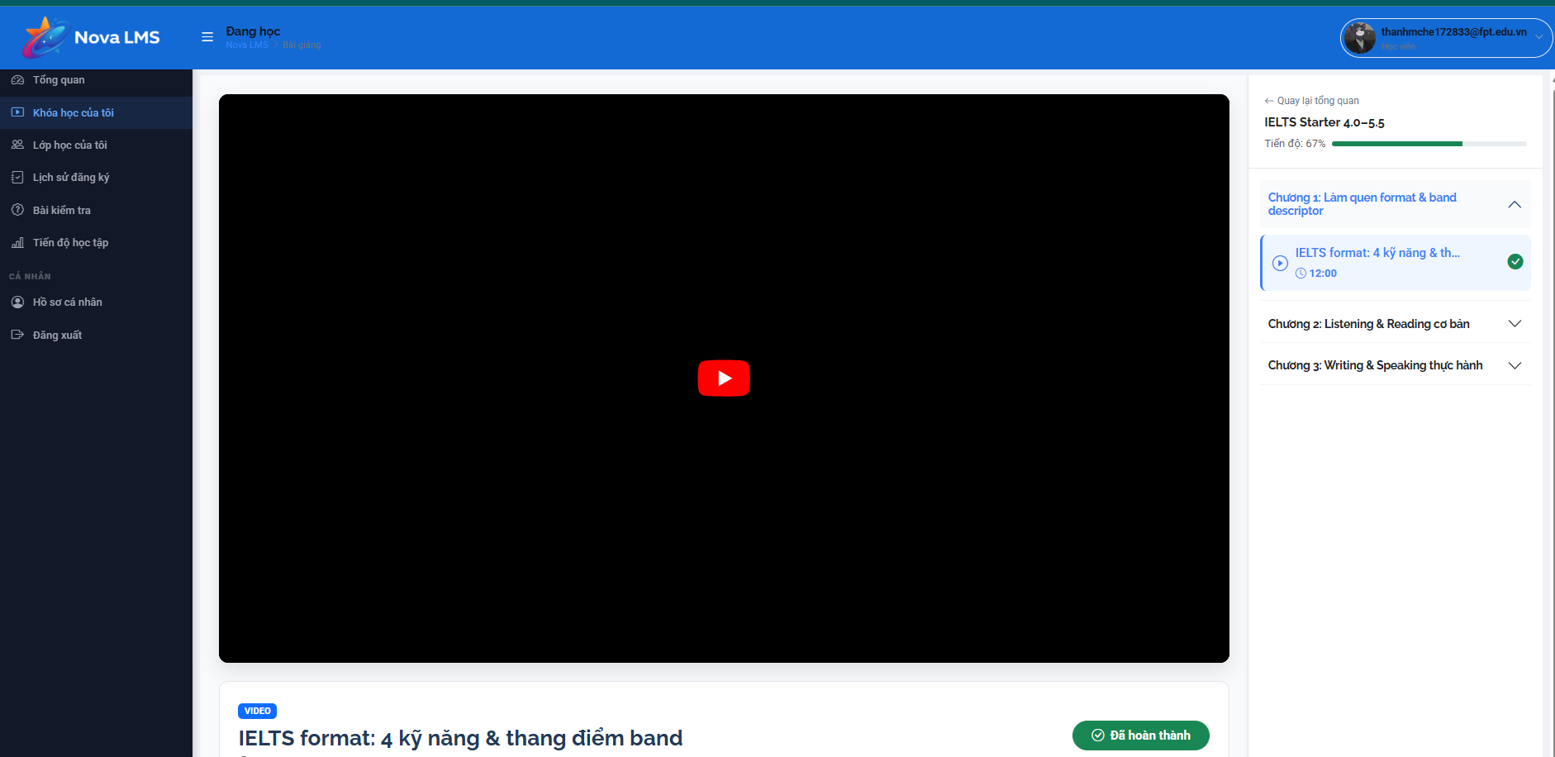

Step 1: From the course learning page, expand a Module to view its Lessons.
Step 2: Click on a Lesson to start learning:
Video lesson: The video player opens inline. If the video is from YouTube, you can play it directly within the page.
Document lesson: The document content is displayed. If a downloadable file is attached, you can click to download or view it depending on the Allow Download setting set by Expert.

3.3.1 Take Quiz / Assignment
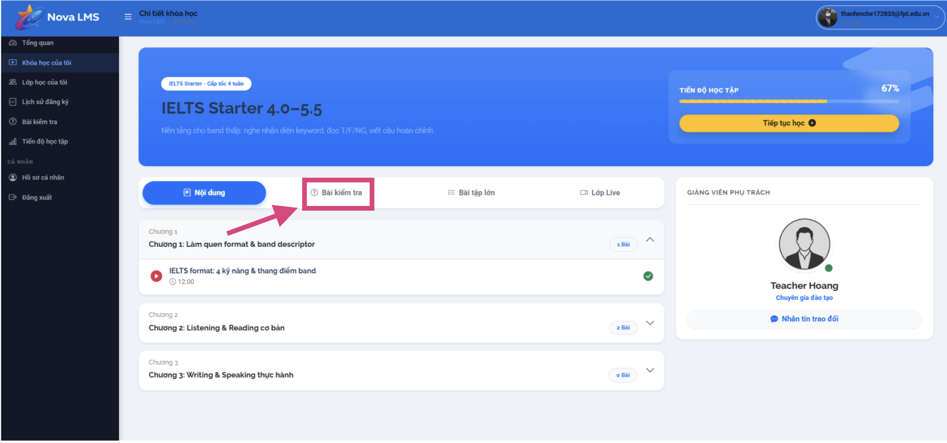
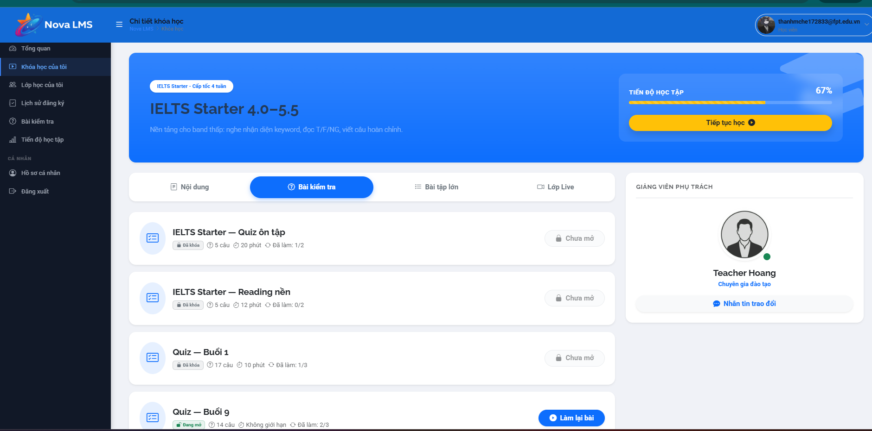
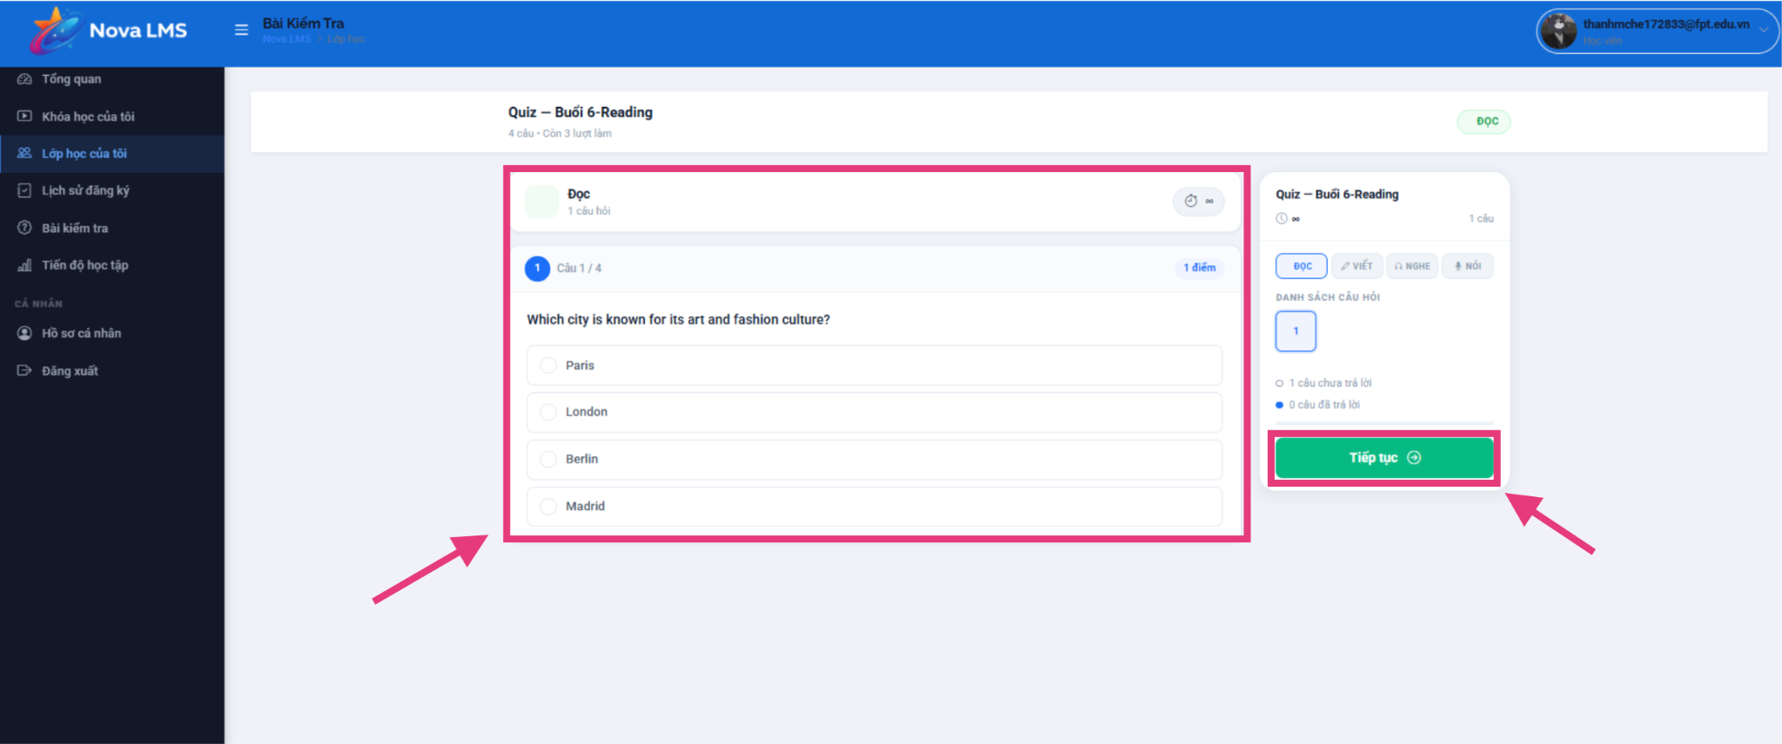
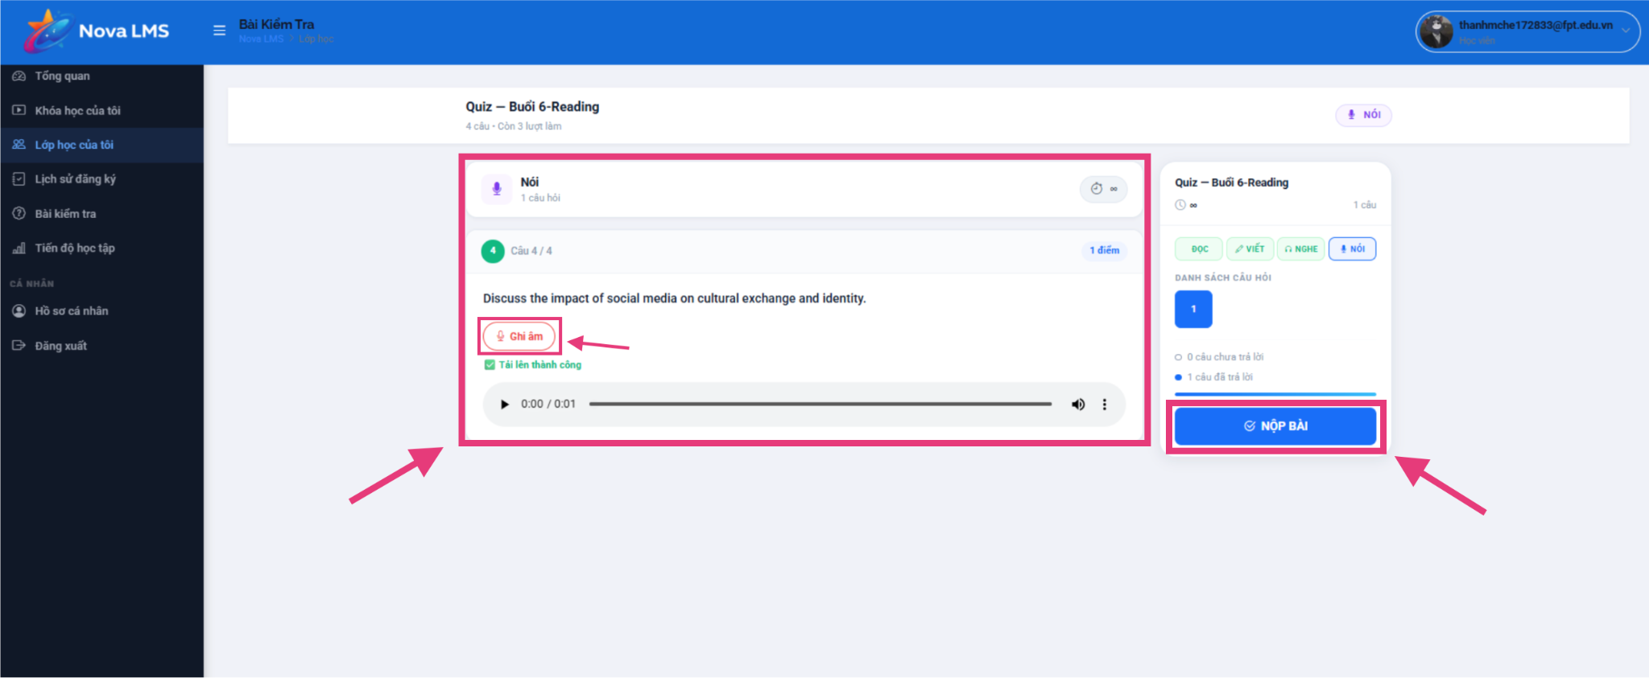
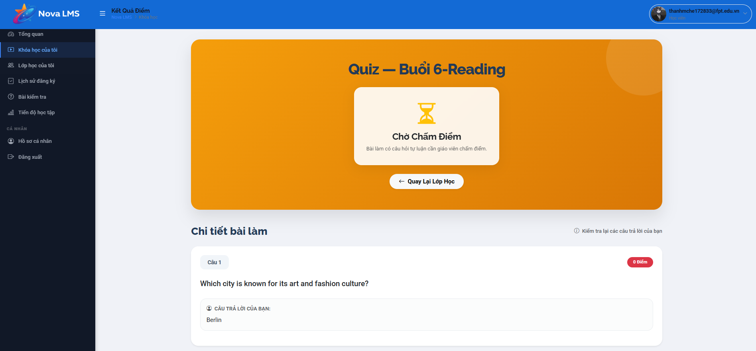
Step 1: Go to Quizzes & Assignments or access via My Courses page. View all assigned quizzes and assignments for your enrolled courses.

Step 2: Click 'Start Quiz' on the quiz/assignment card. The system will display:
- Quiz title, time limit, number of questions
- Click 'Start' to begin
Step 3: Answer all questions. The system supports multiple question types:
- Multiple Choice
- Fill in the Blank
- Matching columns (Matching)
- Writing / Speaking — requires manual grading by Teacher
Step 4: Click 'Submit' before the timer expires. If time runs out, the quiz is auto-submitted.
Step 5: After submitting:
- Automated grading (Listening/Reading): Results are shown immediately.
- Manual grading (Writing/Speaking): Results will be available after Teacher reviews and grades the quiz.
- An email notification will be sent to you once the result is available.
Step 6: View your quiz result and score from the Quizzes & Assignments page or from the Progress page.

3.4 Teacher

3.4.1 Dashboard
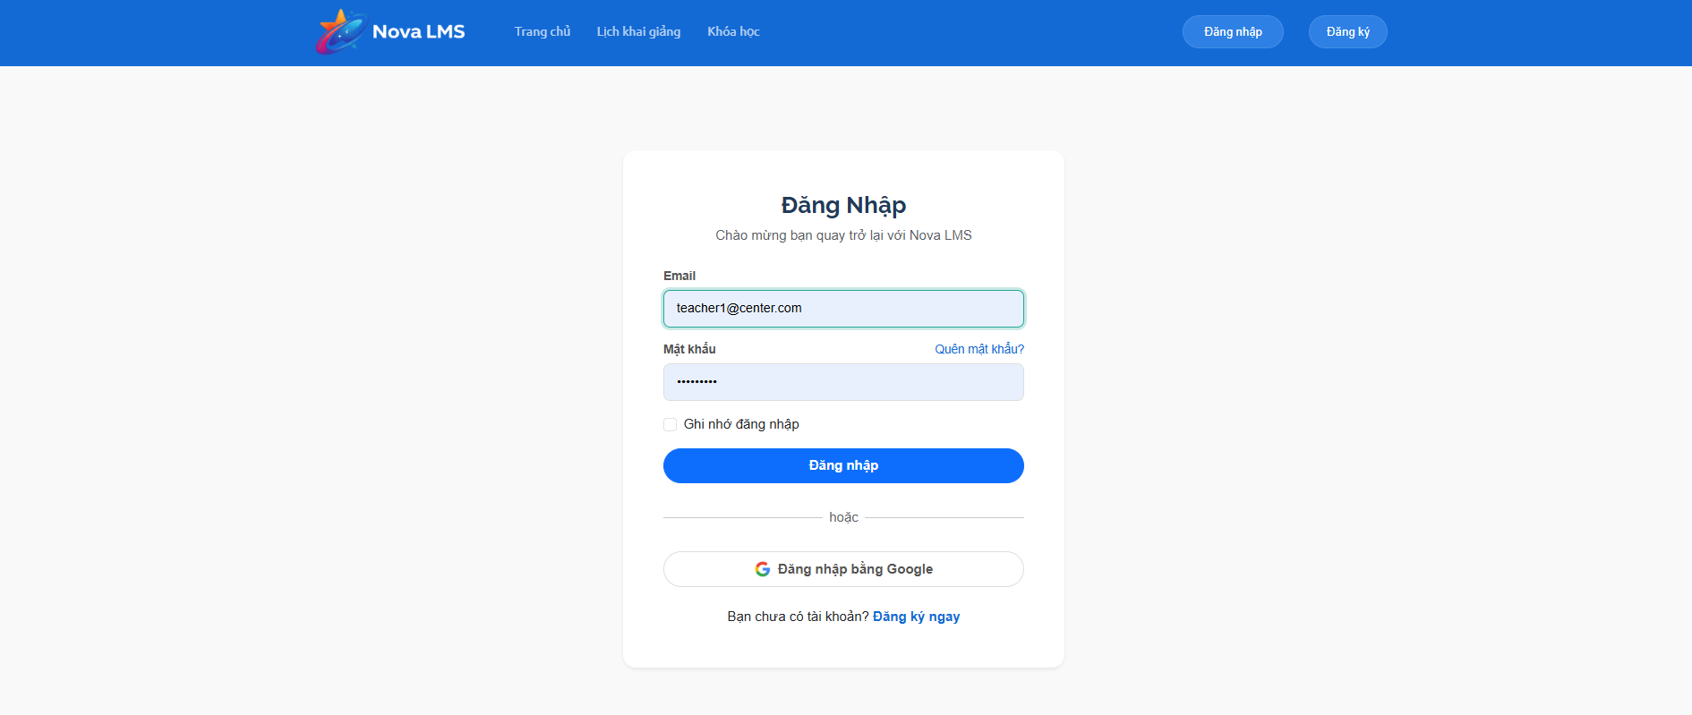
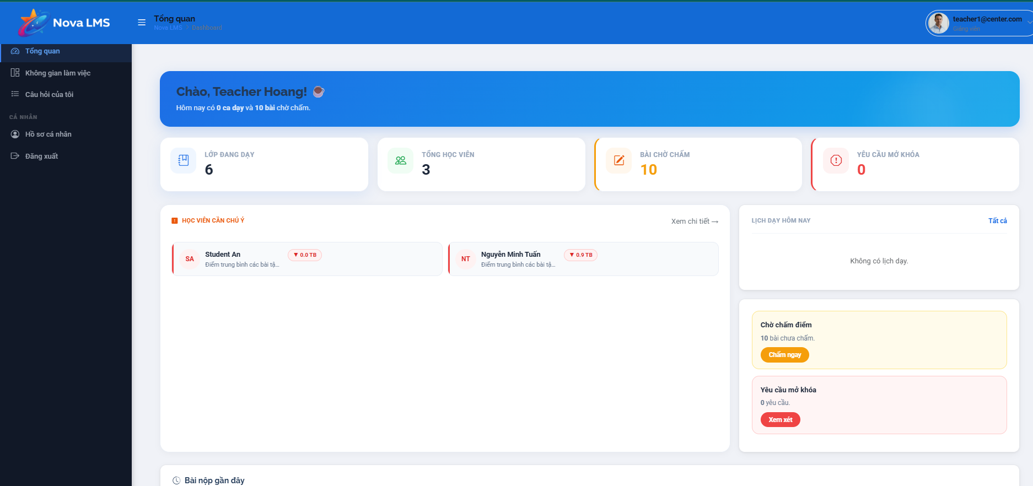
Step 1: Log in with your Teacher account. You will be redirected to the Overview (Dashboard) page.
Step 2: View your dashboard overview:
- Number of Classes (Classes) you are assigned to
- Number of students across all classes
- Recent quiz results require grading
- Overview of upcoming sessions

3.4.2 Manage Classes & Workspace
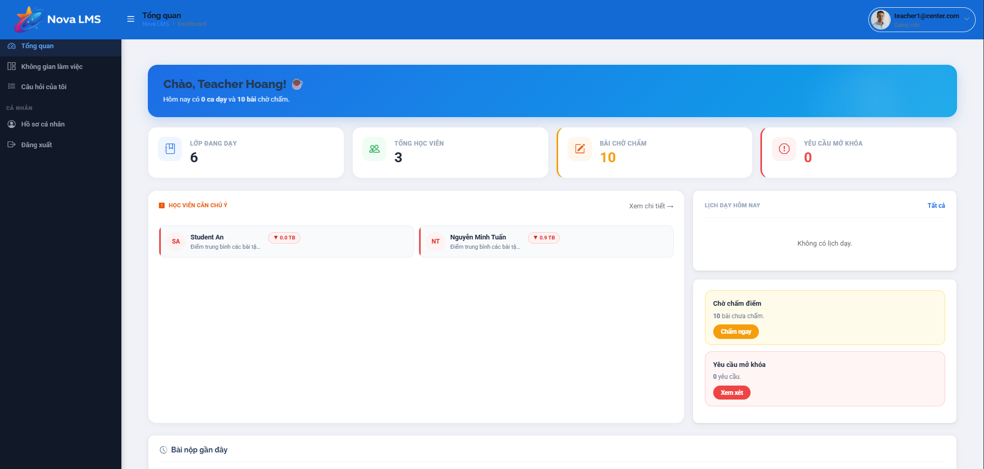
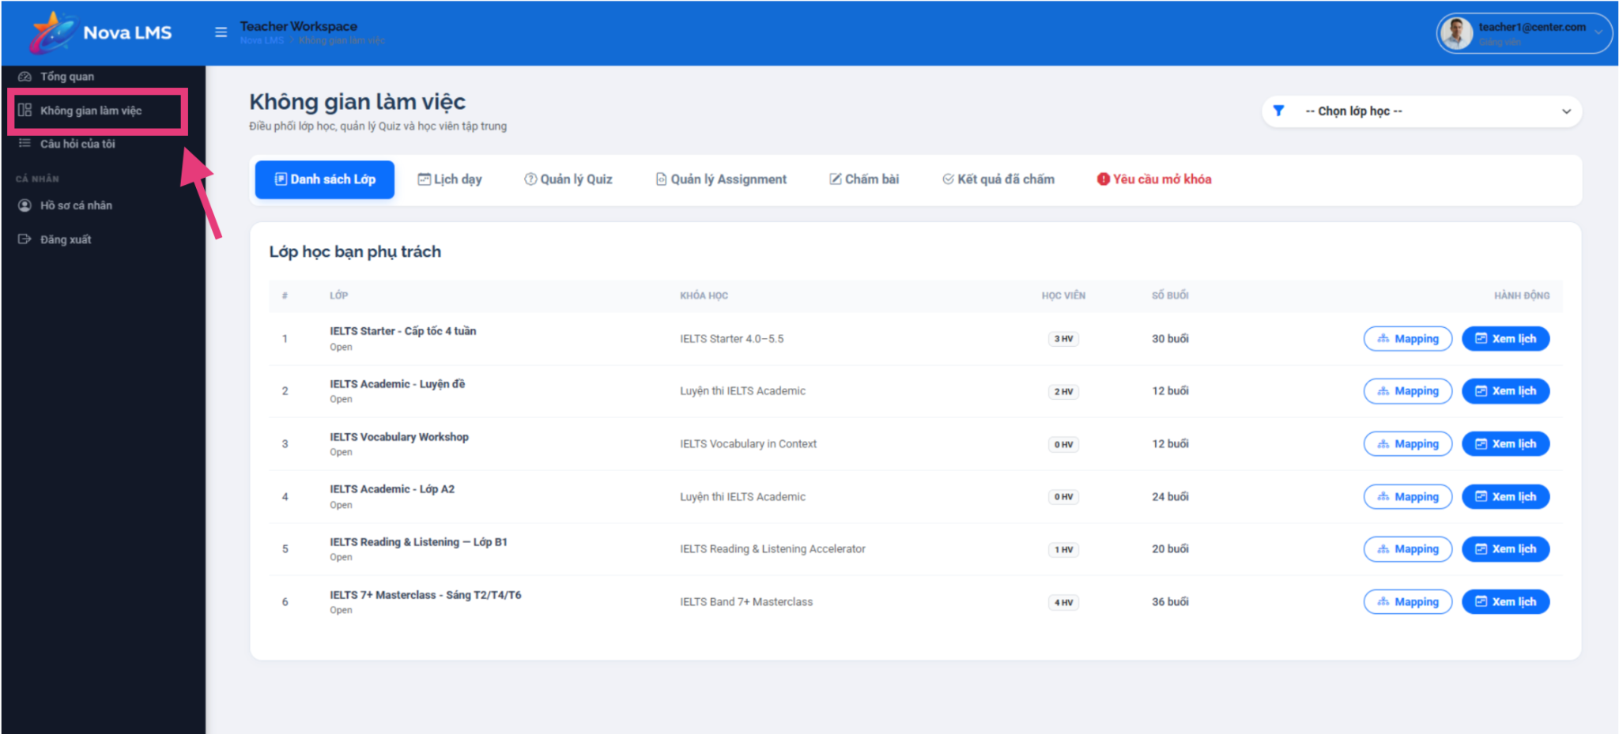
Step 1: Go to the Workspace page.
Step 2: View all your assigned classes. For each class, you can see:
- Class name, assigned course
- Number of registered students
- List of Sessions in each class
- Assigned Quizzes and Assignments linked to each session
- Step 3: Click on a class card to expand and manage its details, sessions, and assessments.

3.4.3 Manage Sessions
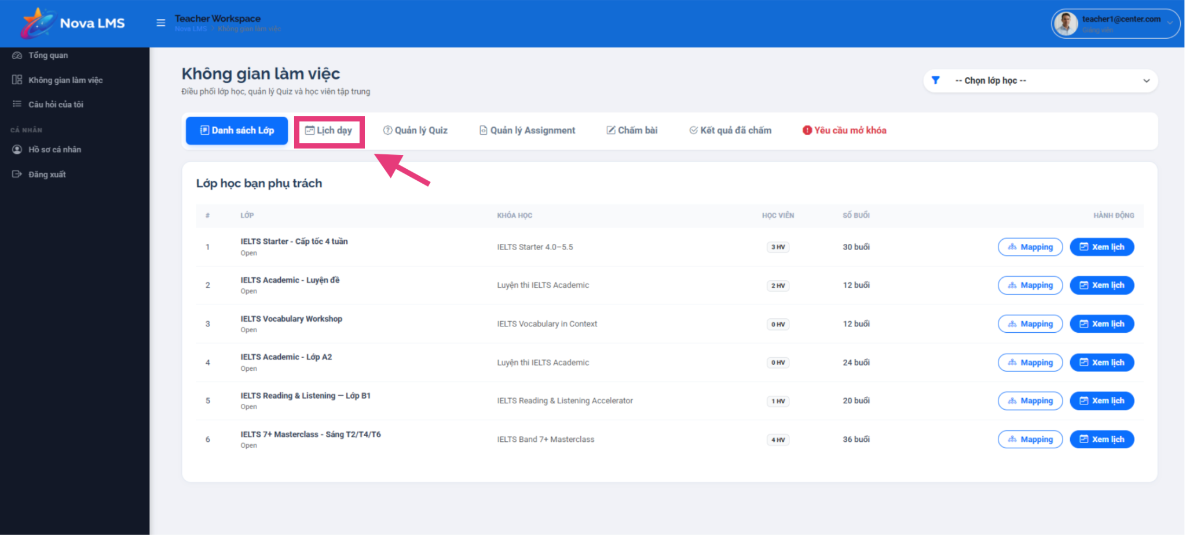
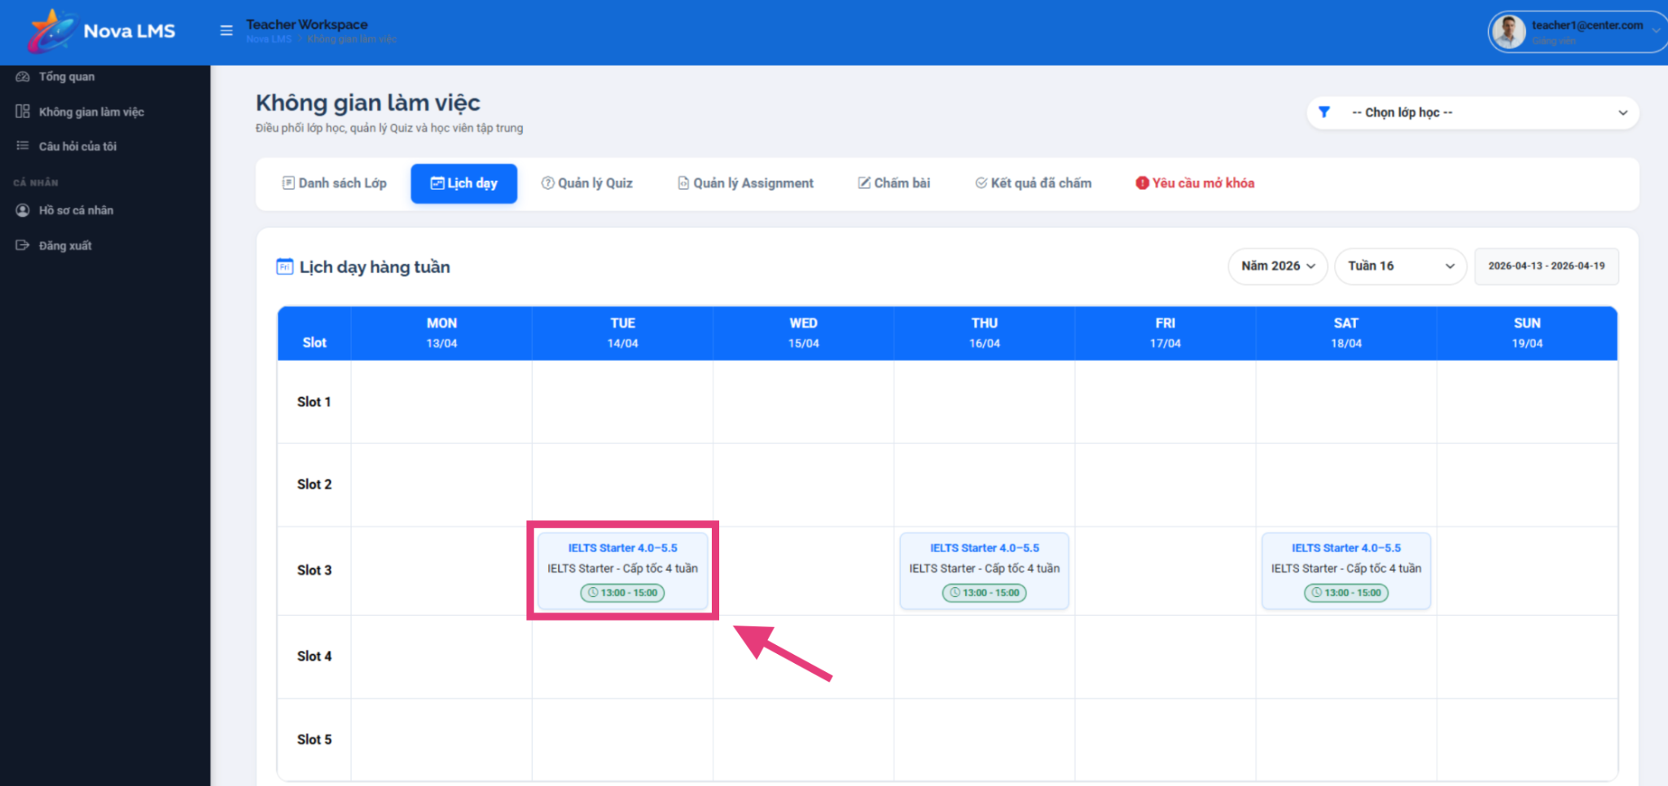
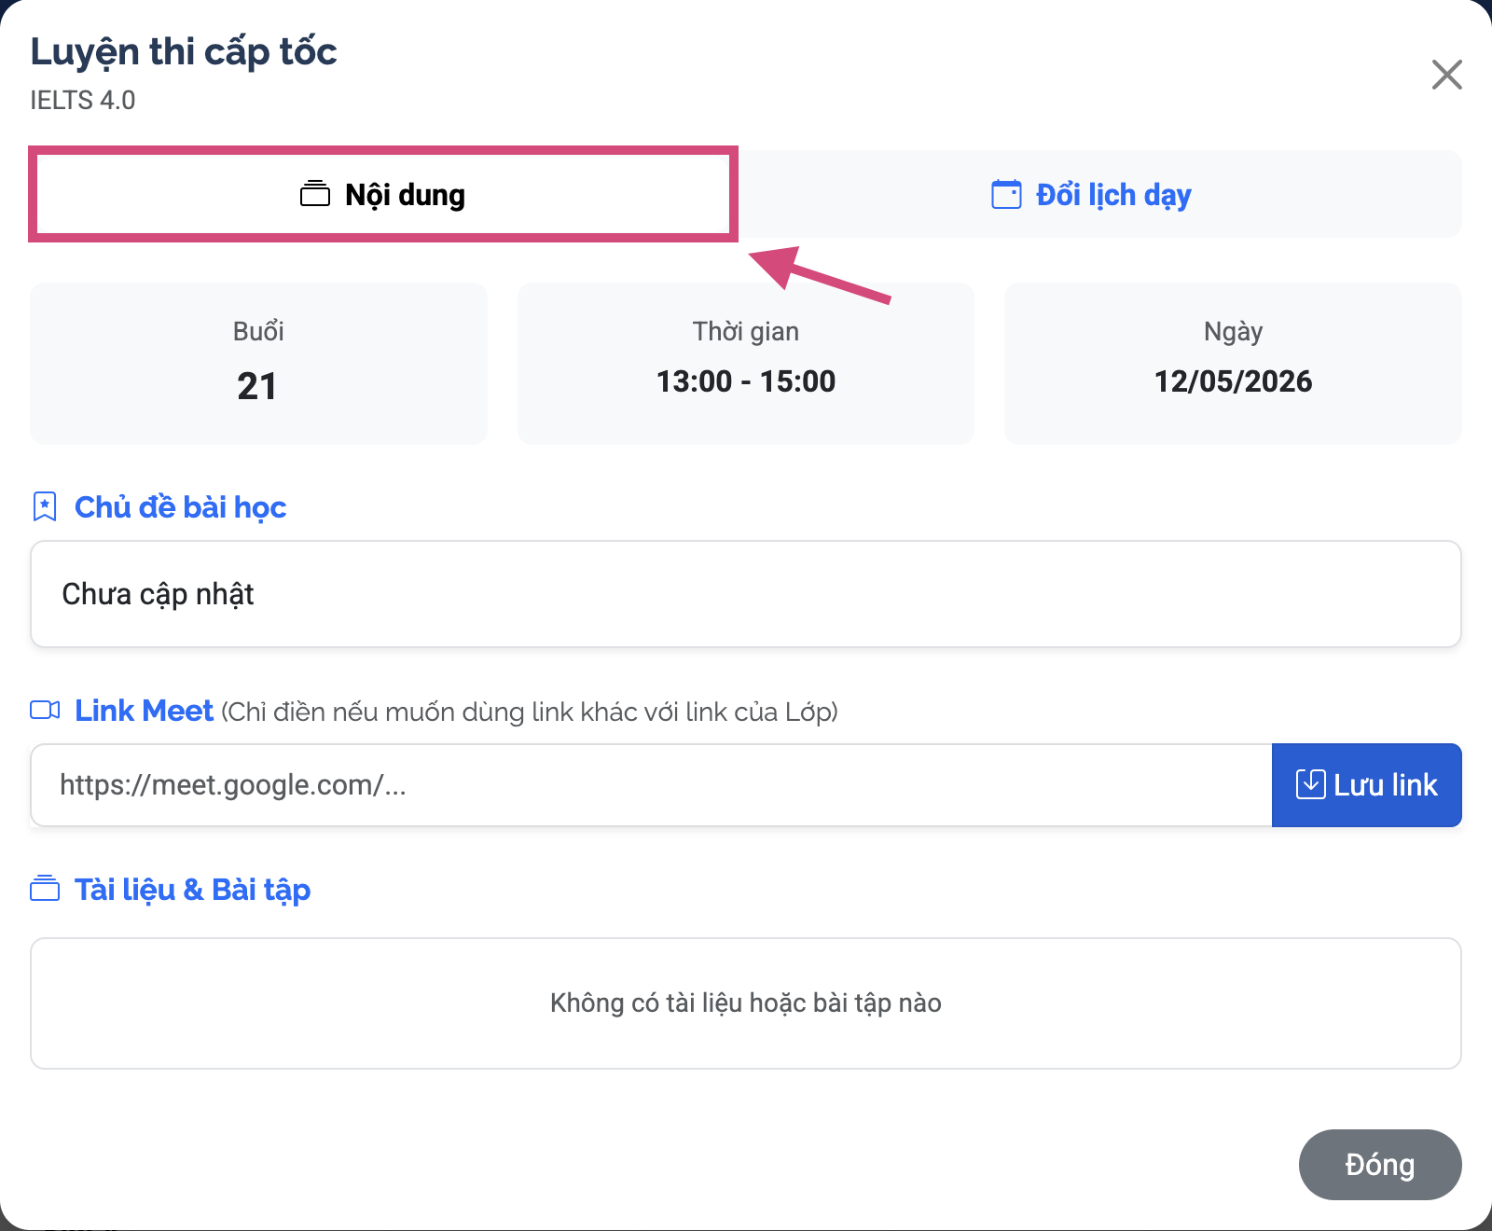
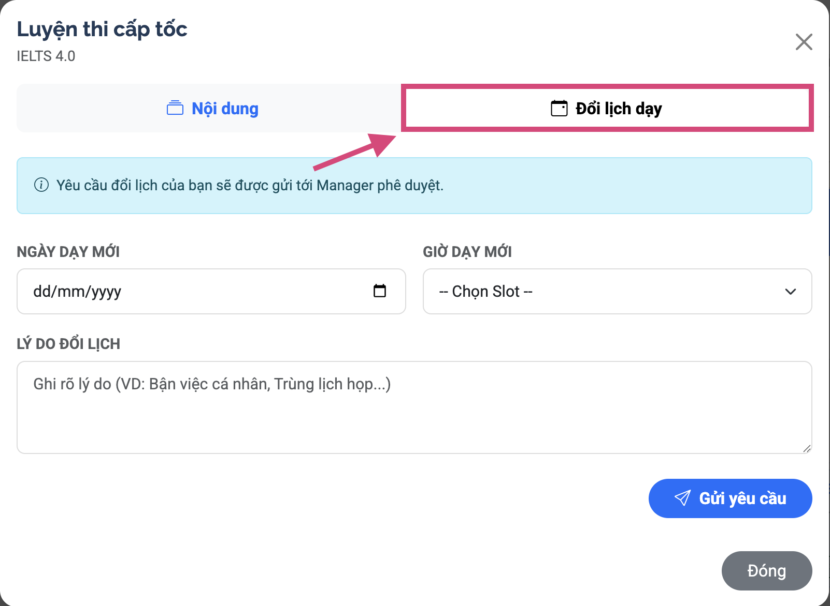
Step 1: From the Workspace or My Classes page, click 'Manage Sessions' on a class card.
Step 2: View all sessions for the class. For each session, you can see:
- Session topic (Session topic)
- Date and time
- Meet link (Meeting link)
- List of attached quizzes/assignments
- Status: Open or Closed
Step 3: Edit or delete a session:
- Click 'Edit' to modify session details. If date/time changes, students will receive a 'Session Rescheduled' email.

3.4.4 Attach Quiz / Assignment to Session
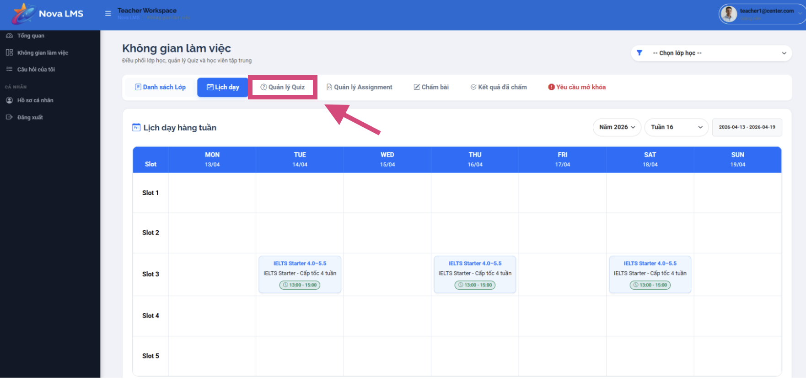
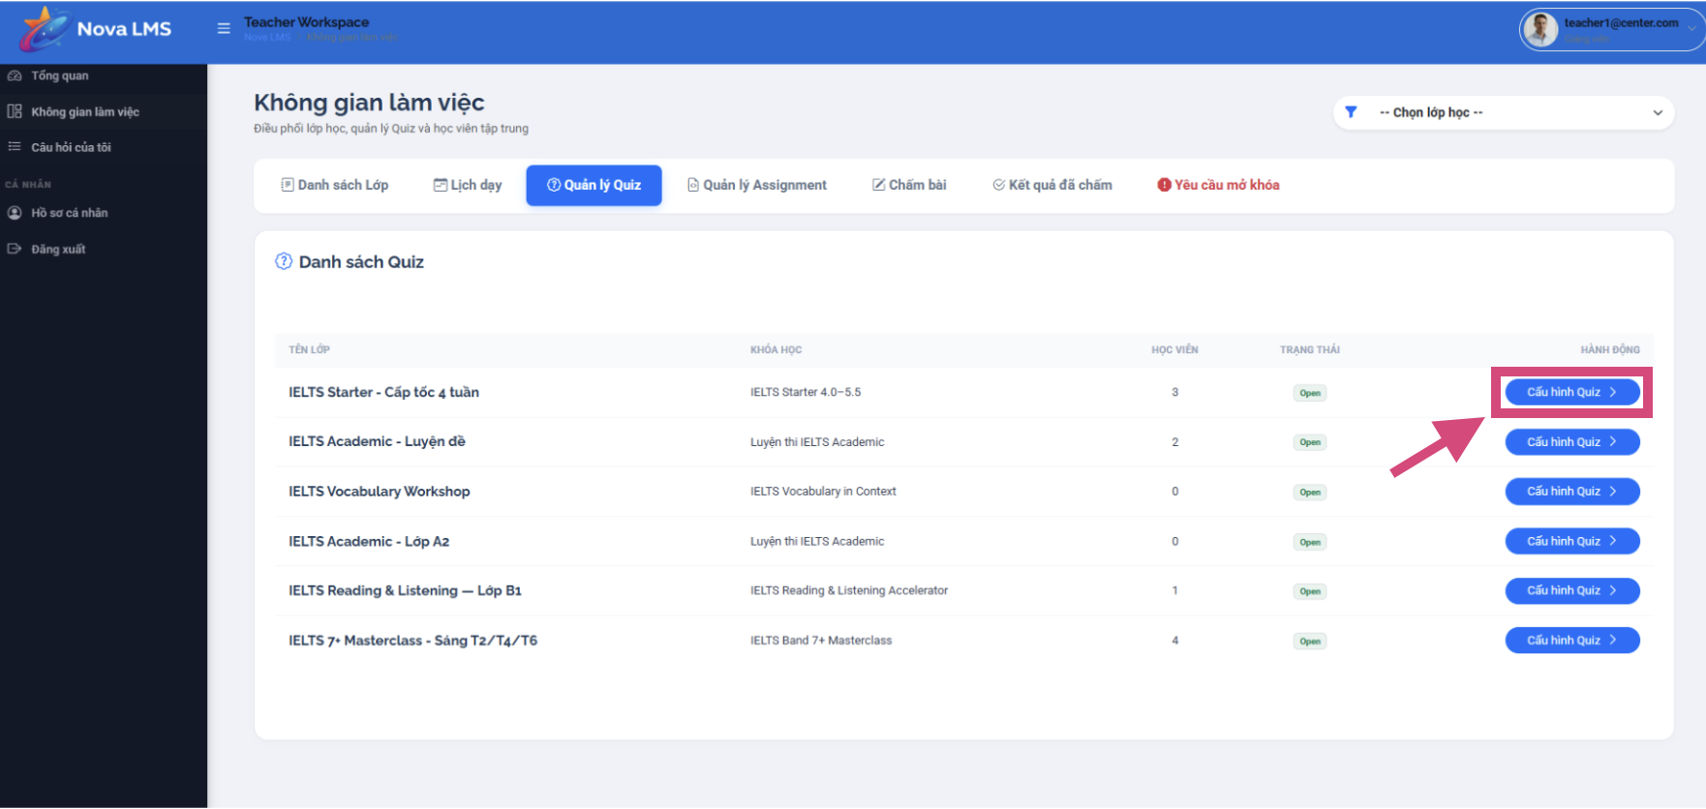
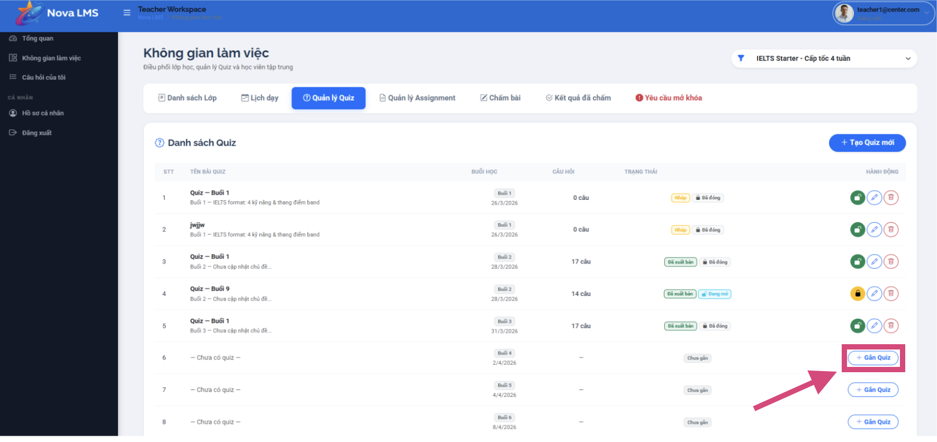
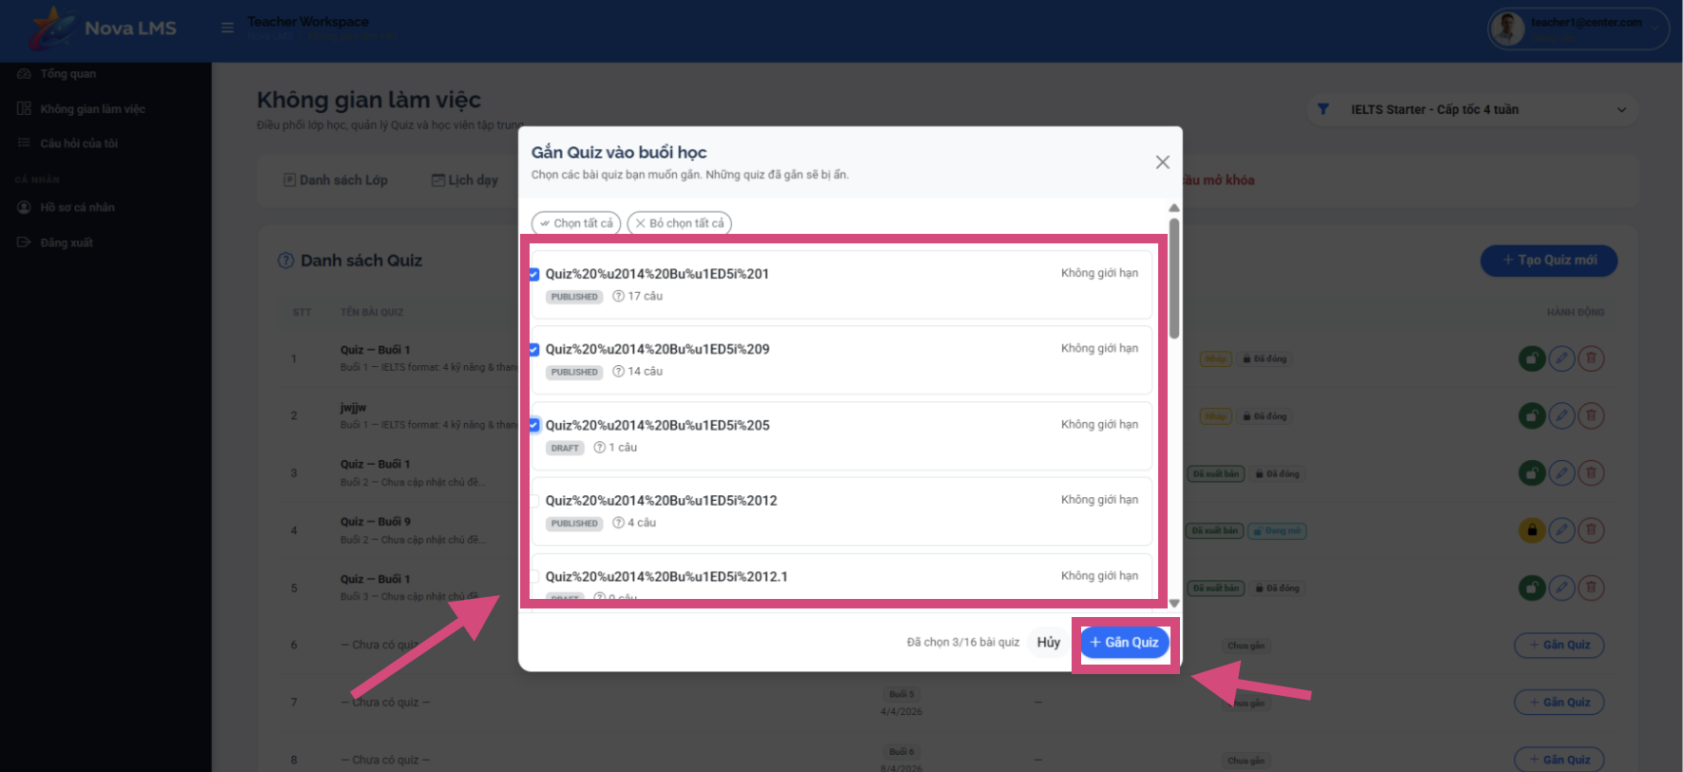
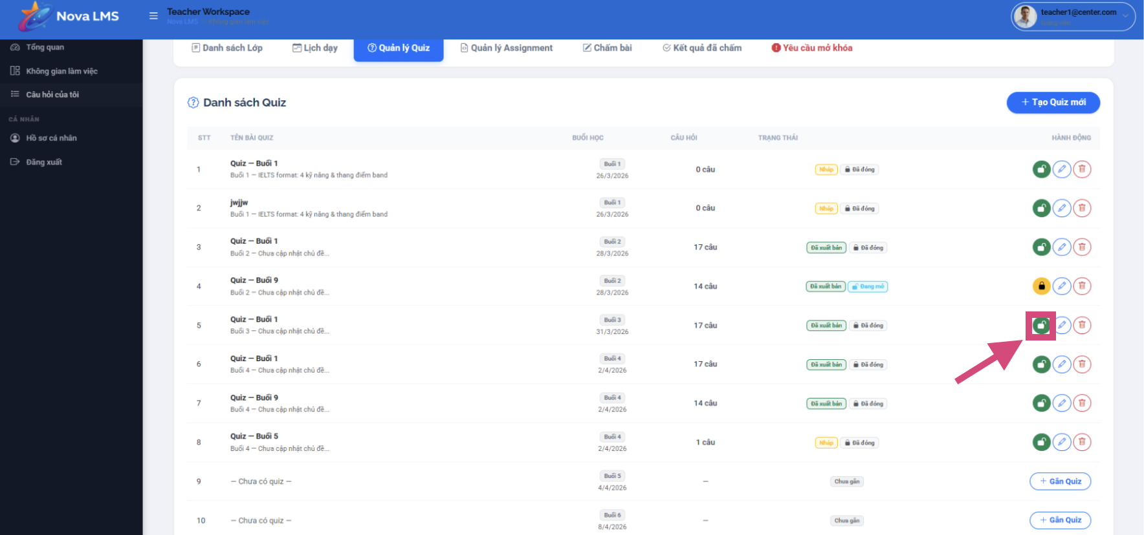
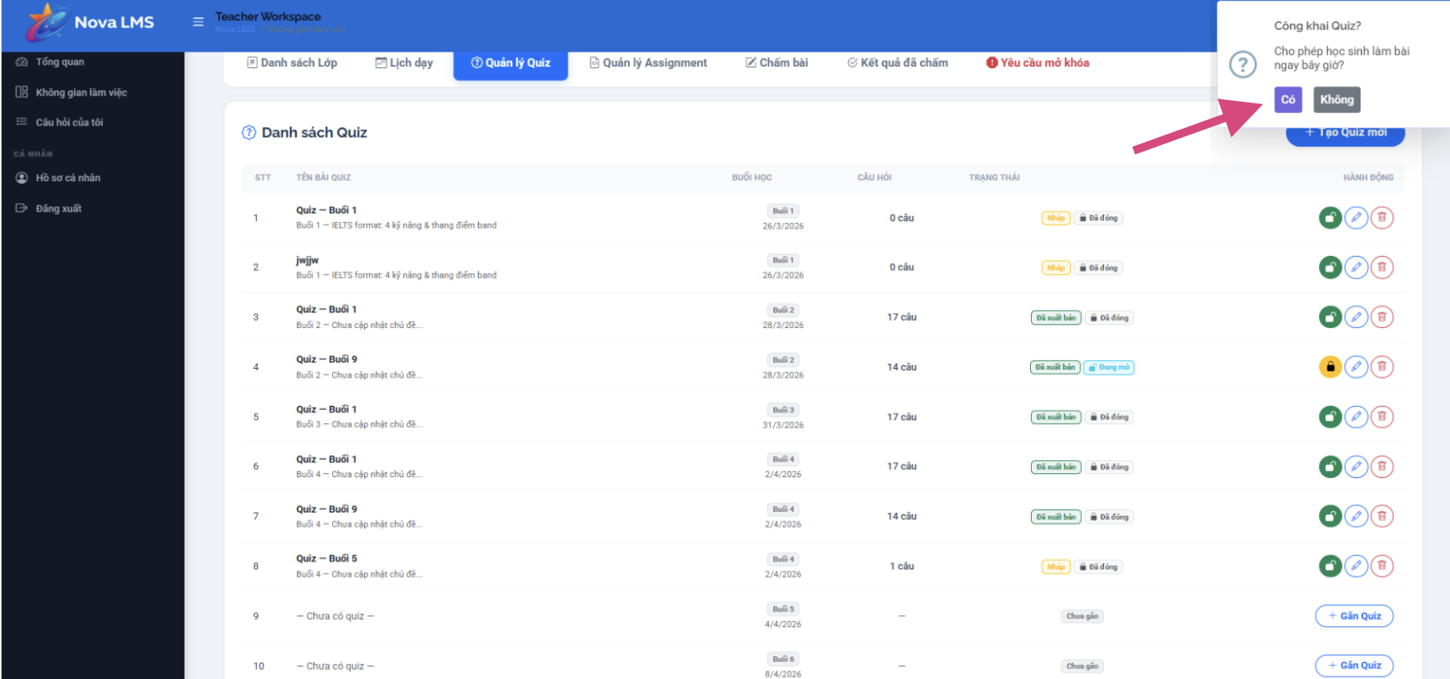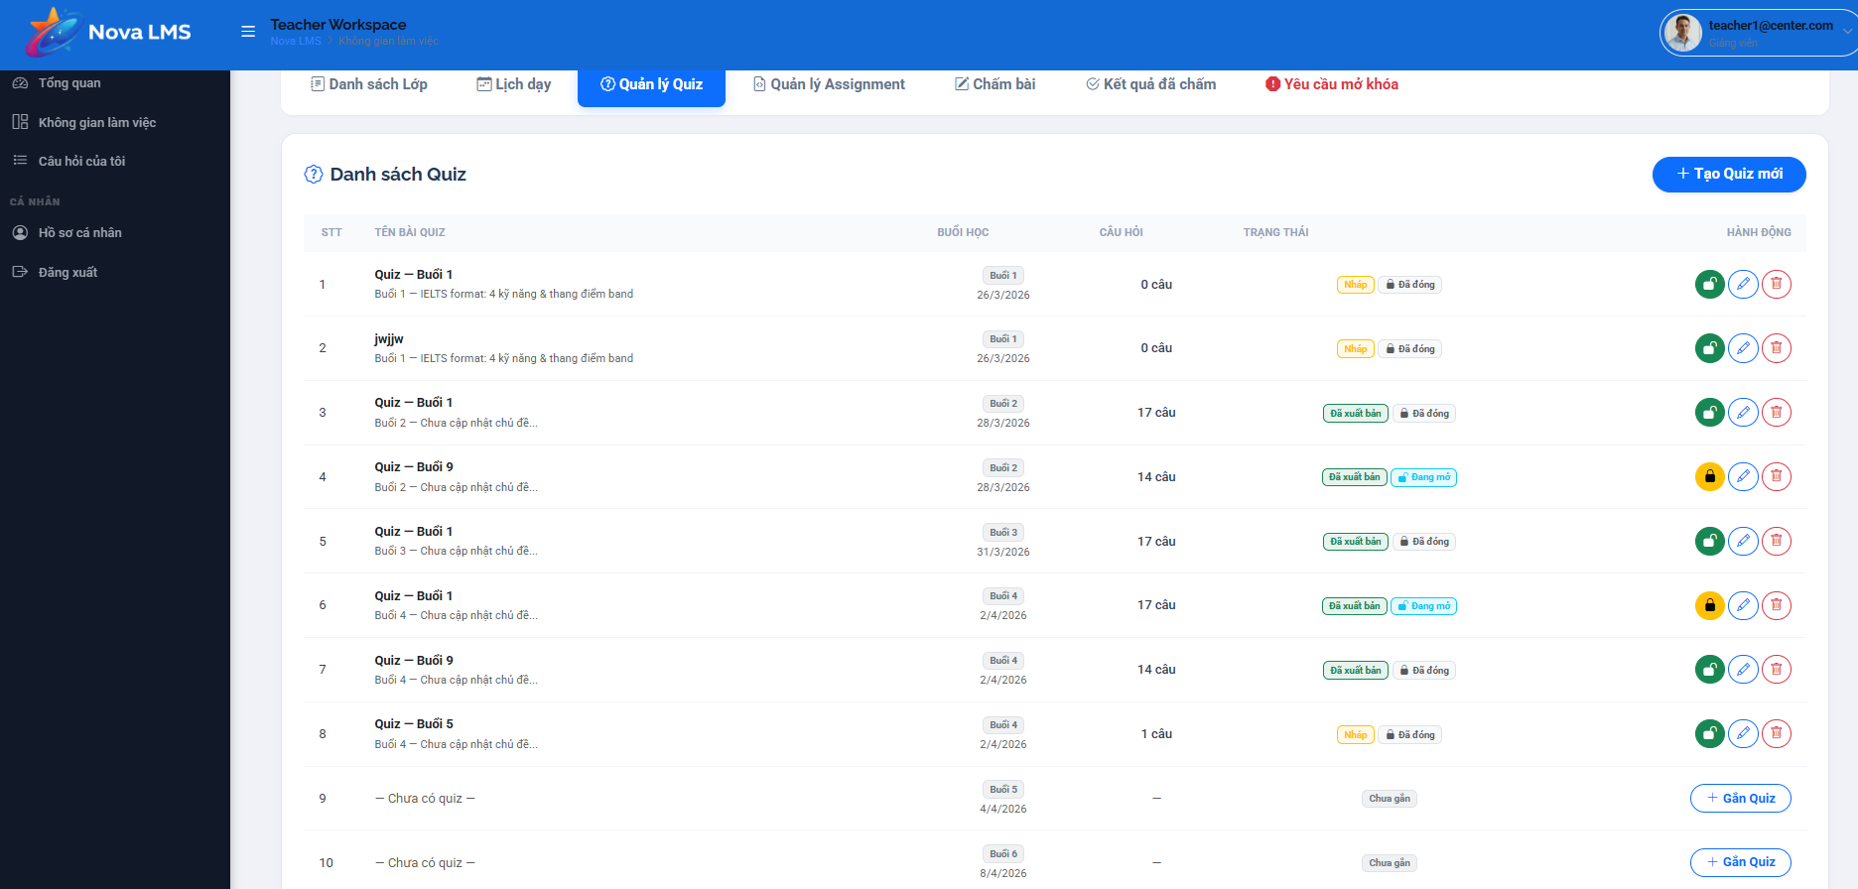
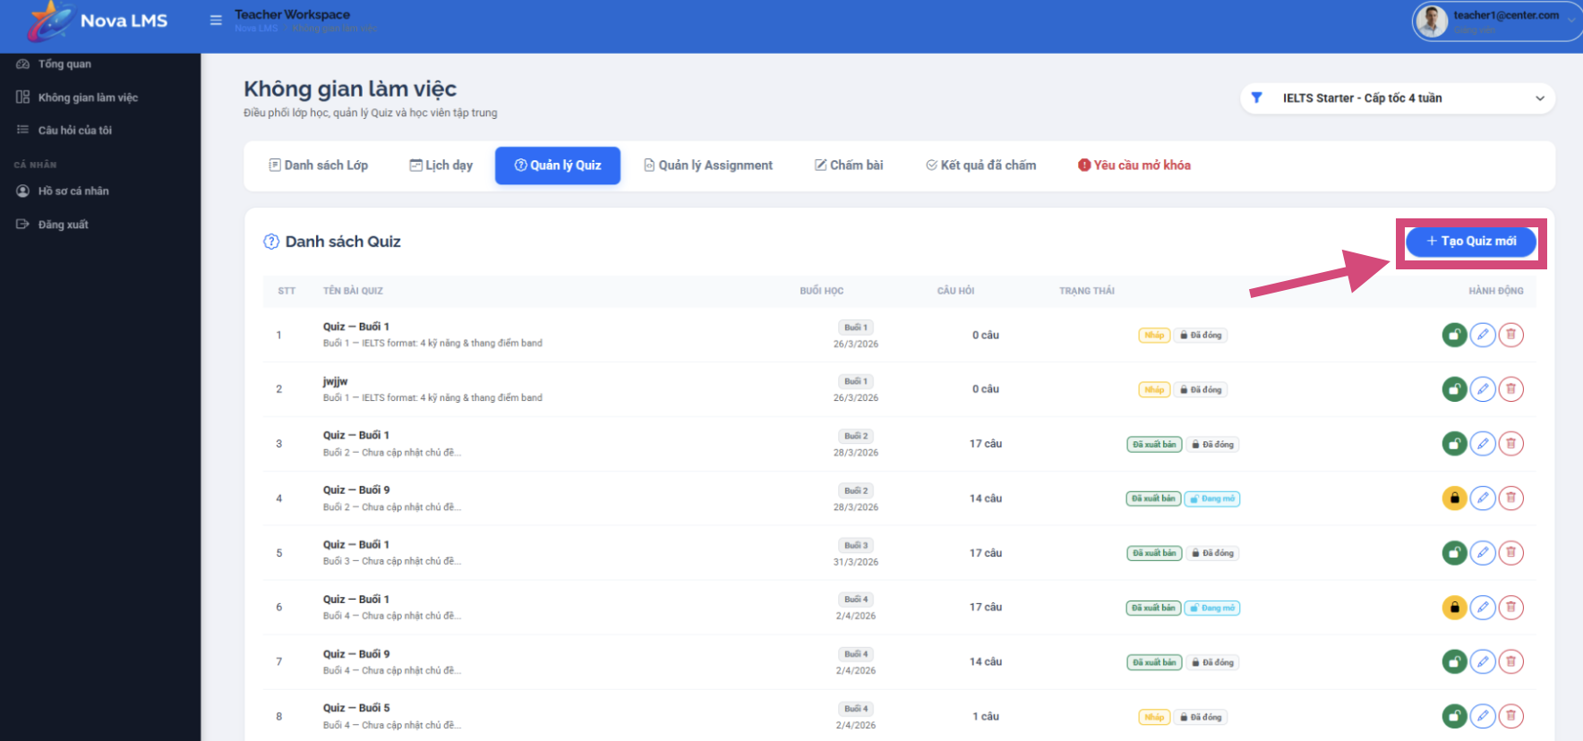
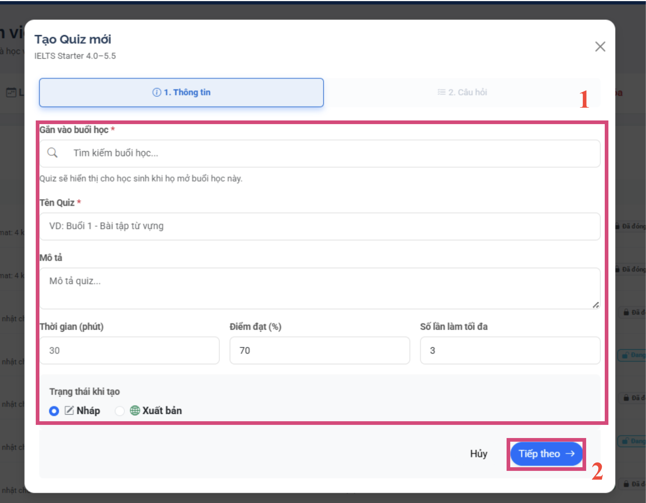
Step 1: From the Session Management page, click the 'Attach Test' or 'Attach Assignment' button.
Step 2: A test selection window will appear. All available tests will be displayed:
- Tests already attached to this session will be hidden and cannot be reselected.
- Select one or more tests from the list.
- Click 'Attach Selected'.
Step 3: View the attached tests in the session's test list. For each assigned test, you can:
- Open/Close — turn the test's availability on/off for students
- Open All/Close All — turn it on/off in bulk
- Remove — delete the test from the session (the test will not be deleted)
- Click 'Edit' to manage questions or test settings
Step 4: To create a new test directly:
- Click 'Create Test' on the Session Management page. Fill in the test details: title, description, time limit, passing score, maximum number of attempts, question order.
- Add questions from the Question Bank or create questions using AI.
- Click 'Publish' when finished. Students will receive an email notification.

3.4.5 Grade Quizzes & Assignments
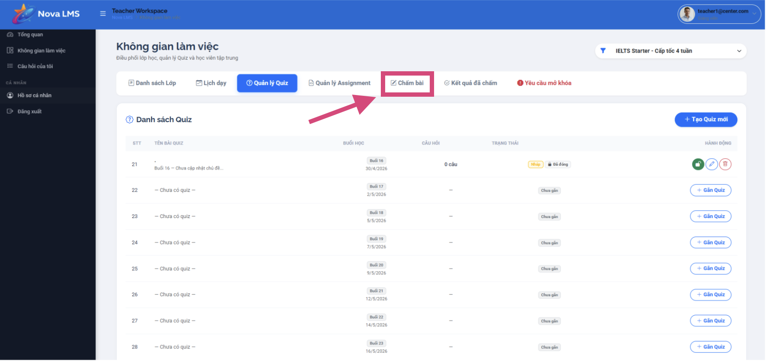
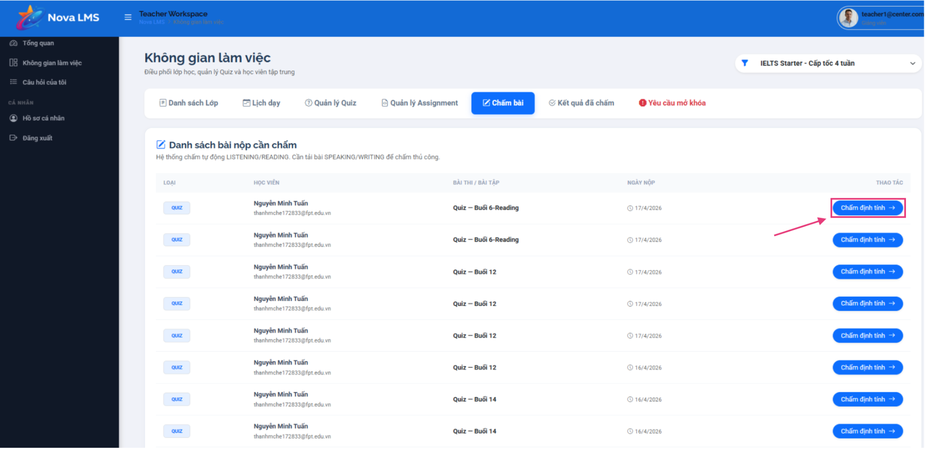
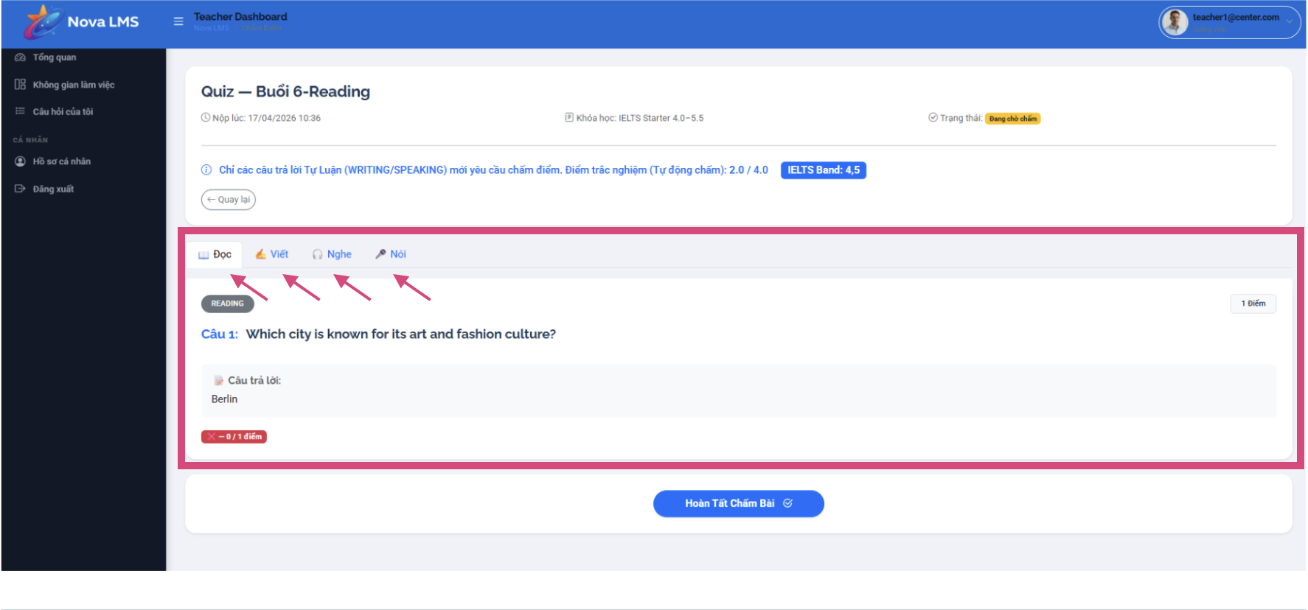
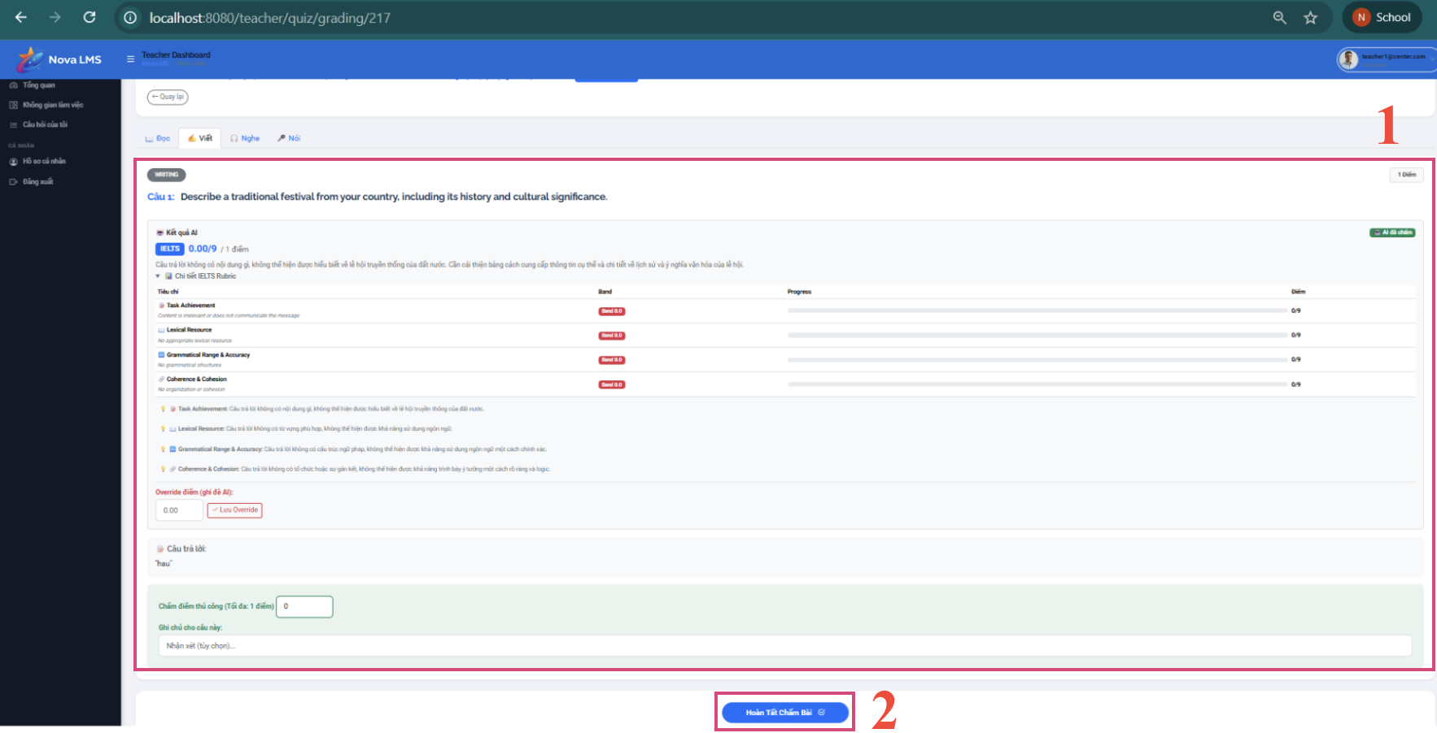
Step 1: Go to the Grading section from the sidebar or dashboard.
Step 2: View the list of quiz results pending grading. Filter by:
- Quiz type: LESSON_QUIZ or ASSIGNMENT
- Status: Submitted, Graded
Step 3: Click on a result to open the grading detail page. You will see:
- Student name, quiz title, submission time
- All questions with student's answers and your score per question
- Auto-graded questions (Listening, Reading) are pre-scored
- Manual-graded questions (Writing, Speaking) require your input
Step 4: For manual grading:
- Review the student's answers for Writing/Speaking questions.
- Enter score for each question.
- Optionally add feedback/notes.
- Click 'Submit Grade' to save.
Step 5: After grading, the student will receive an email notification with their results.

3.4.6 AI Question Generation
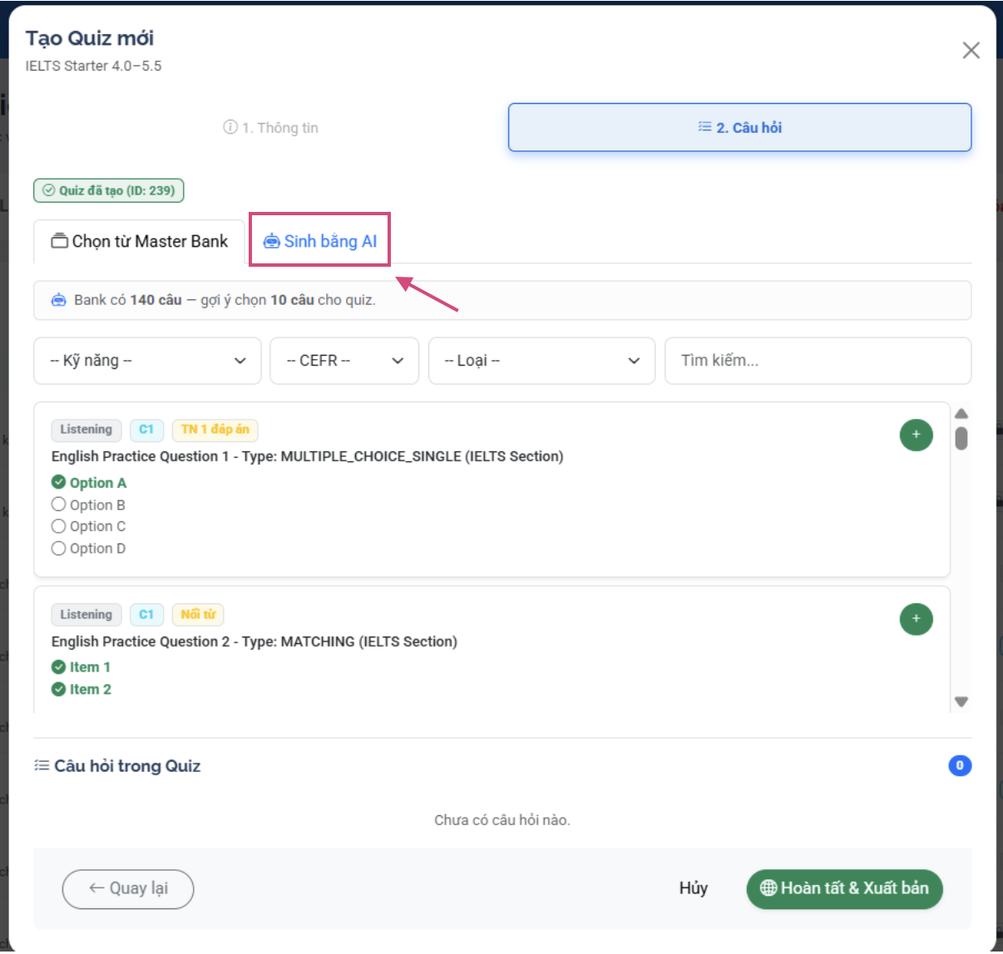
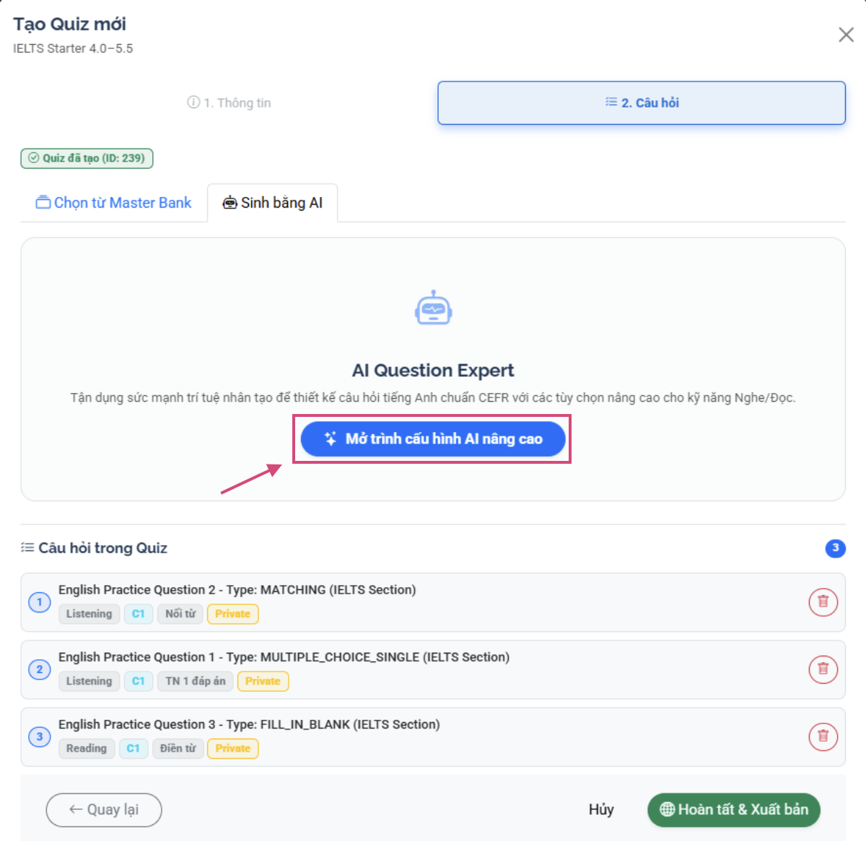
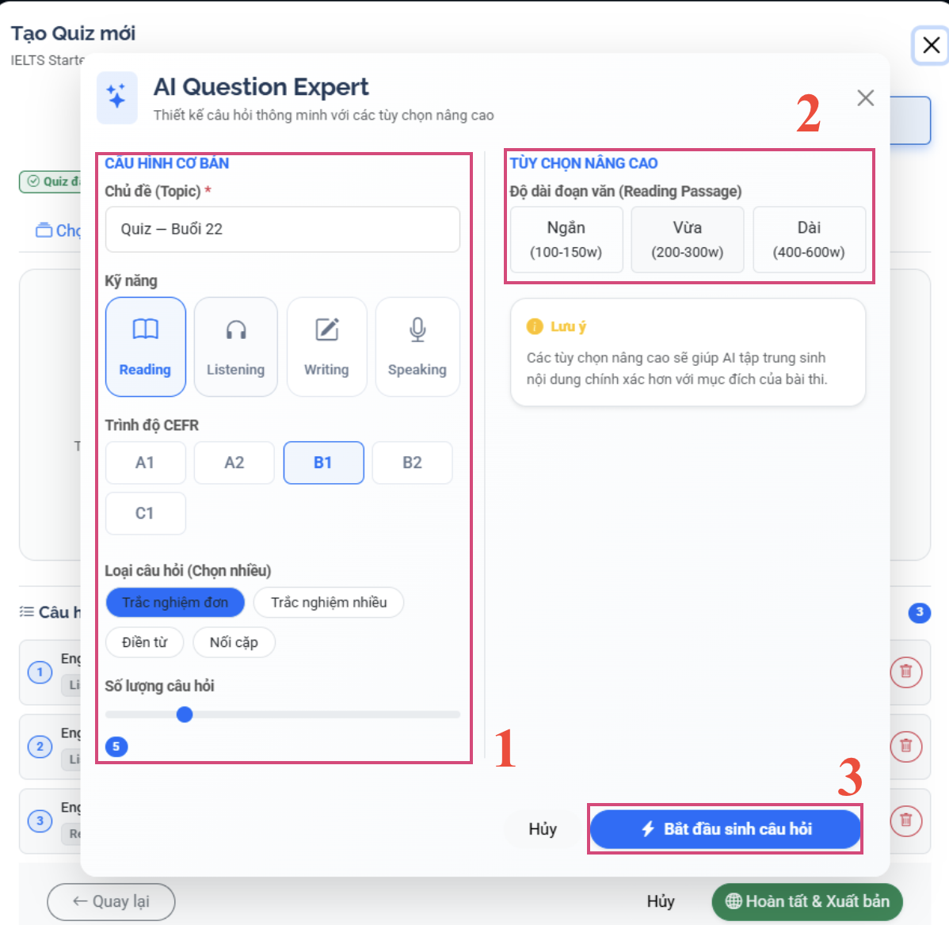
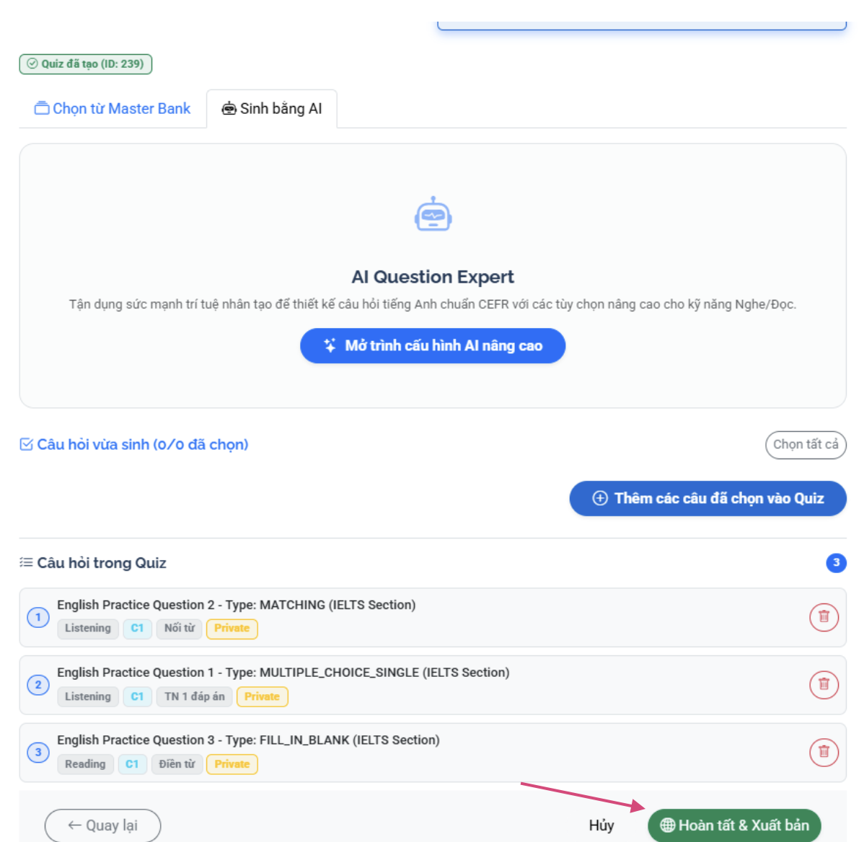

Step 1: From the Session Management page, click the 'Manage Quiz' or 'Manage Assignments' button.
Step 2: A quiz selection window will appear. All available quizzes will be displayed.
- Quizzes already attached to this session will be hidden and cannot be selected again.
- Select one or more quizzes from the list.
- Click 'Attach selected quizzes'.
Step 3: View the attached quizzes in the session's quiz list. For each attached test, you can:
- Open/Close — turn the test display on/off for students
- Open All / Close All — turn on/off bulk
- Remove — delete the test from the session (the test is not deleted)
- Click 'Edit' to manage questions or test settings
Step 4: To create a new test directly:
- Click 'Create Test' on the session management page.
- Fill in the test details: title, description, time limit, passing score, maximum number of attempts, question order.
- Add questions from the Question Bank or create using AI.
- Click 'Publish' when finished. Students will receive an email notification.

3.5 Expert

3.5.1 Manage Course Content
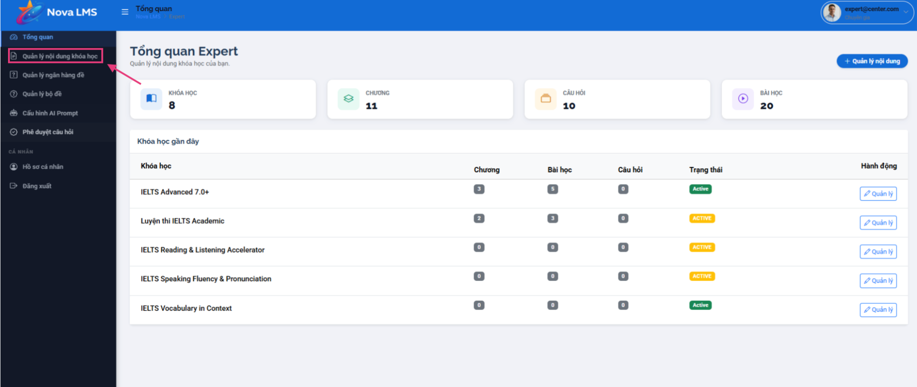
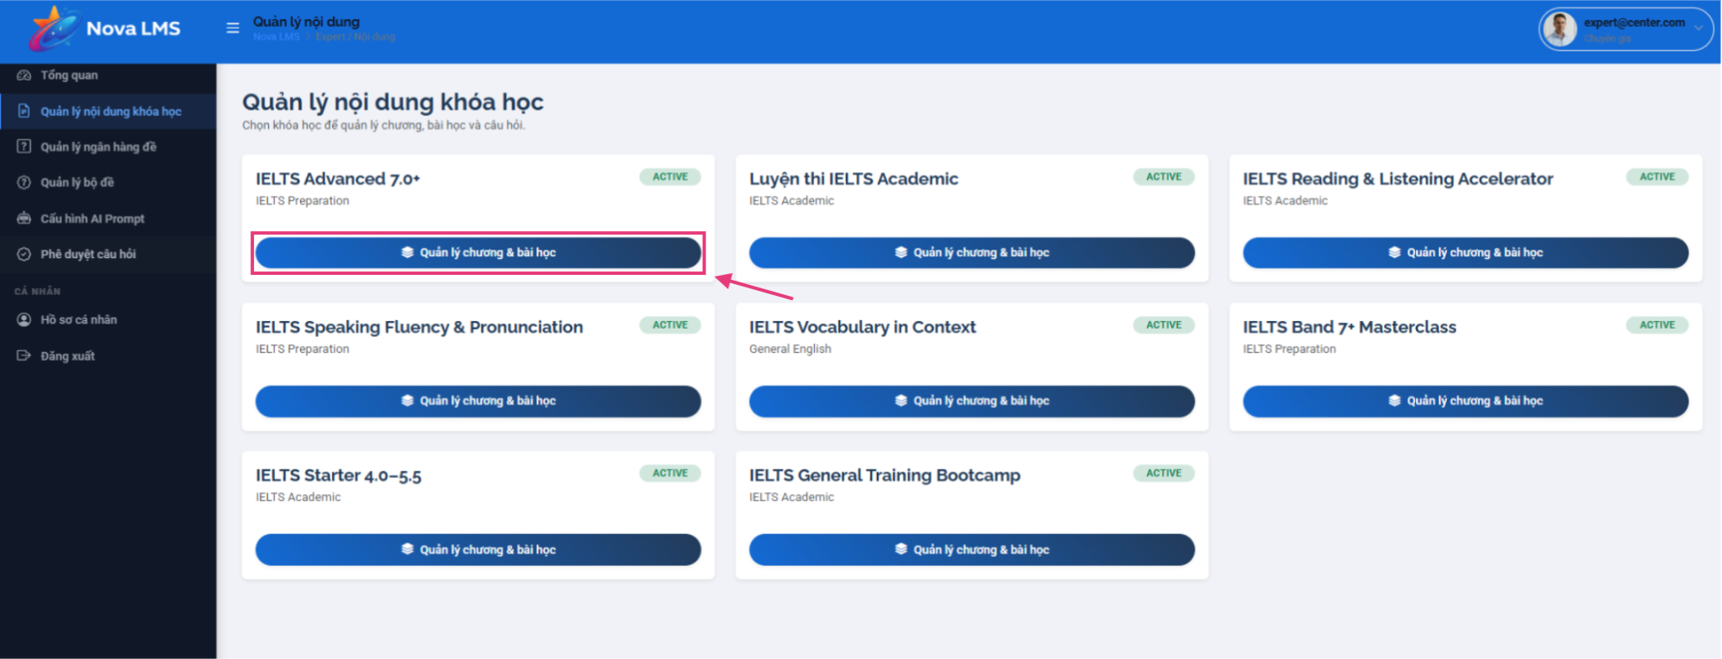

Step 1: Go to Content Management from the sidebar.
Step 2: View all courses assigned to you. Click 'Manage Modules & Lessons' on a course card.
Step 3: View the course structure. You will see all Module (Chapter) cards with their lesson counts.

3.5.1 Manage Modules and Lessons
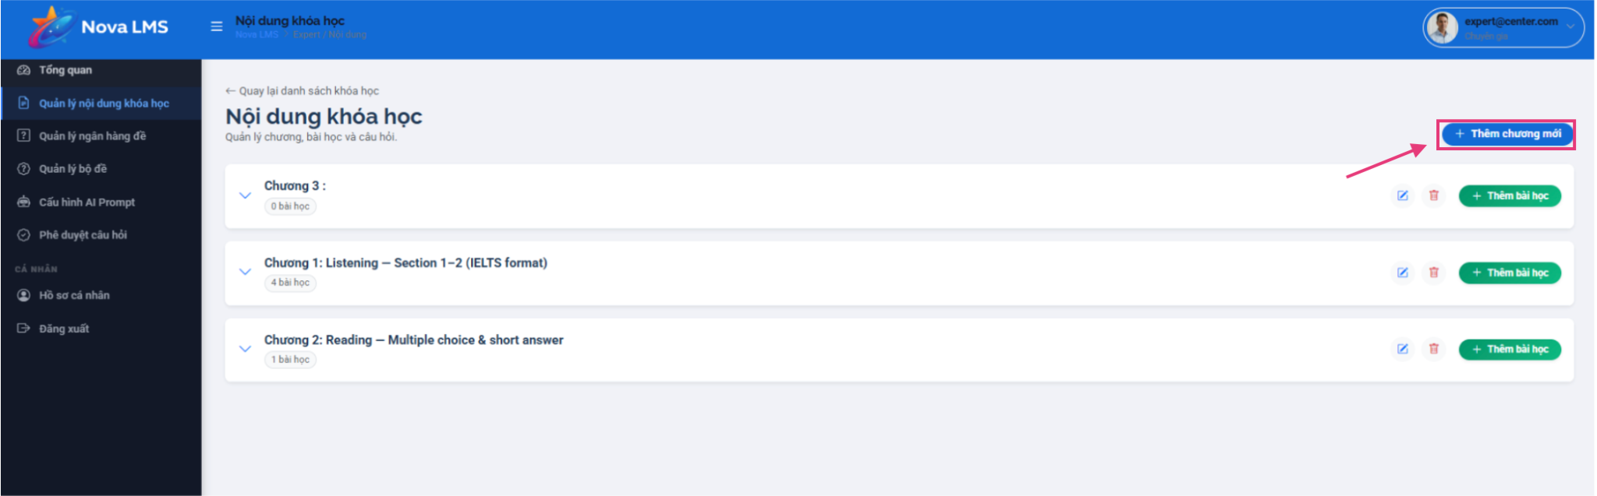
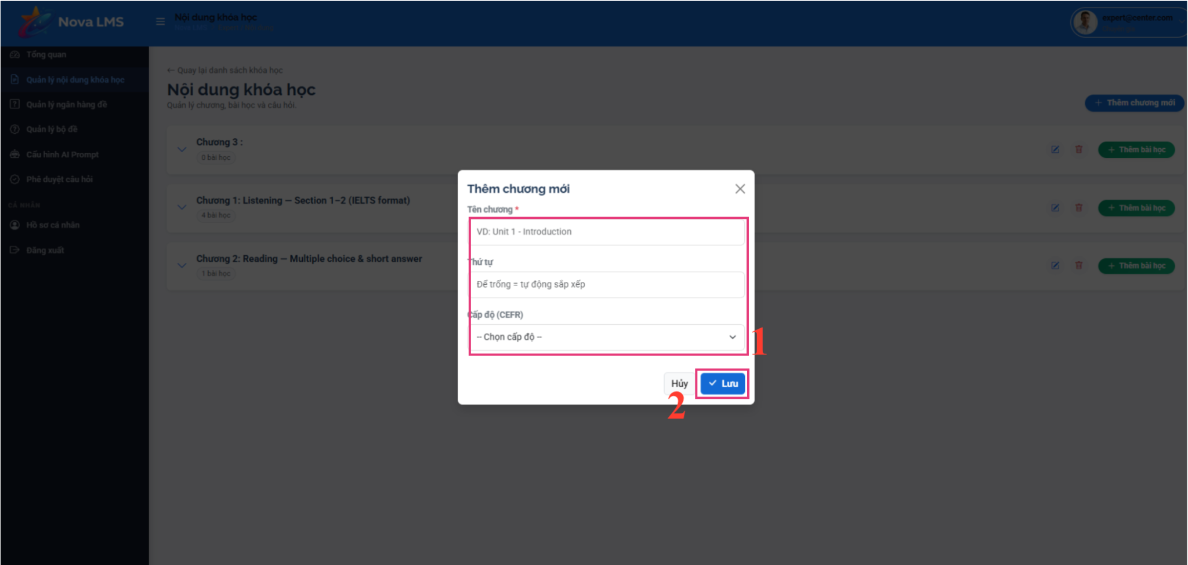
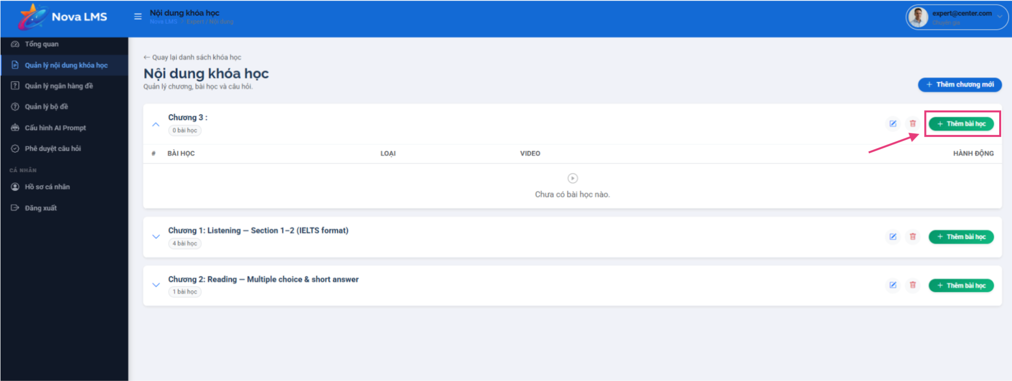
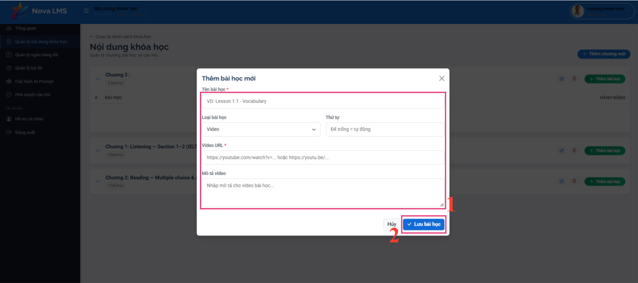
Step 1: Click 'Thêm chương mới' (Add Module) at the top of the course content page.
Step 2: Fill in module details:
- Tên chương (Module Name)
- Thứ tự (Order) — optional, auto-sorted if left blank
- Cấp độ CEFR (CEFR Level) — select A1, A2, B1, B2, C1, or C2
- Step 3: Click 'Lưu' (Save) to create the module.
Step 4: For each module card, you can:
- Sửa chương (Edit) — modify module name, level, or order
- Xóa chương (Delete) — remove the module and all its lessons
- Thêm bài học (Add Lesson) — create a new lesson within this module
Step 5: Click 'Thêm bài học' (Add Lesson) on a module card. The lesson modal will open.
Step 6: Fill in lesson details:
- Tên bài học (Lesson Name)
- Loại bài học (Lesson Type): select Video or Tài liệu (Document)
Step 7: For Video lessons:
- Enter Video URL — must be a valid YouTube link (youtube.com/watch, youtu.be, or youtube.com/shorts)
- The system will preview the video when a valid URL is entered
- Add Mô tả video (Video Description) — optional
Step 8: For Tài liệu (Document) lessons:
- Enter Mô tả / Nội dung tóm tắt (Content Summary) — required
- Optionally attach a file (.docx, .pdf) by clicking the upload field
- Toggle Cho phép tải tài liệu (Allow Download) to enable/disable student downloads
Step 9: Click 'Lưu bài học' (Save Lesson) to create the lesson.
Step 10: For each lesson in the module table, you can:
- Sửa (Edit) — modify lesson content
- Xóa (Delete) — remove the lesson
- Xem video (View Video) — preview the video in a popup (for Video lessons)

3.6 Admin

3.6.1 User Management
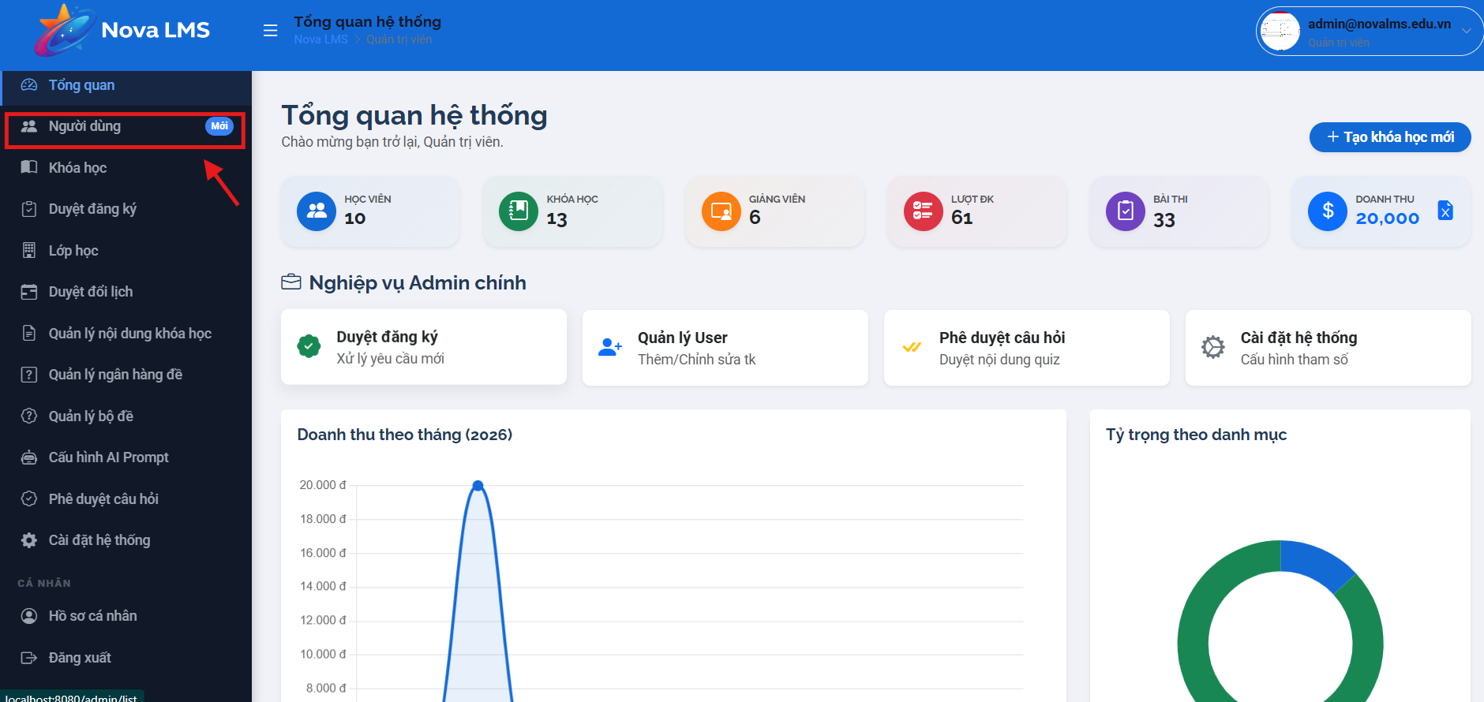

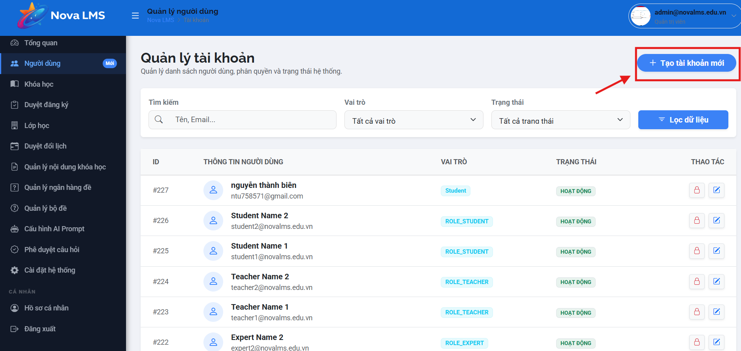
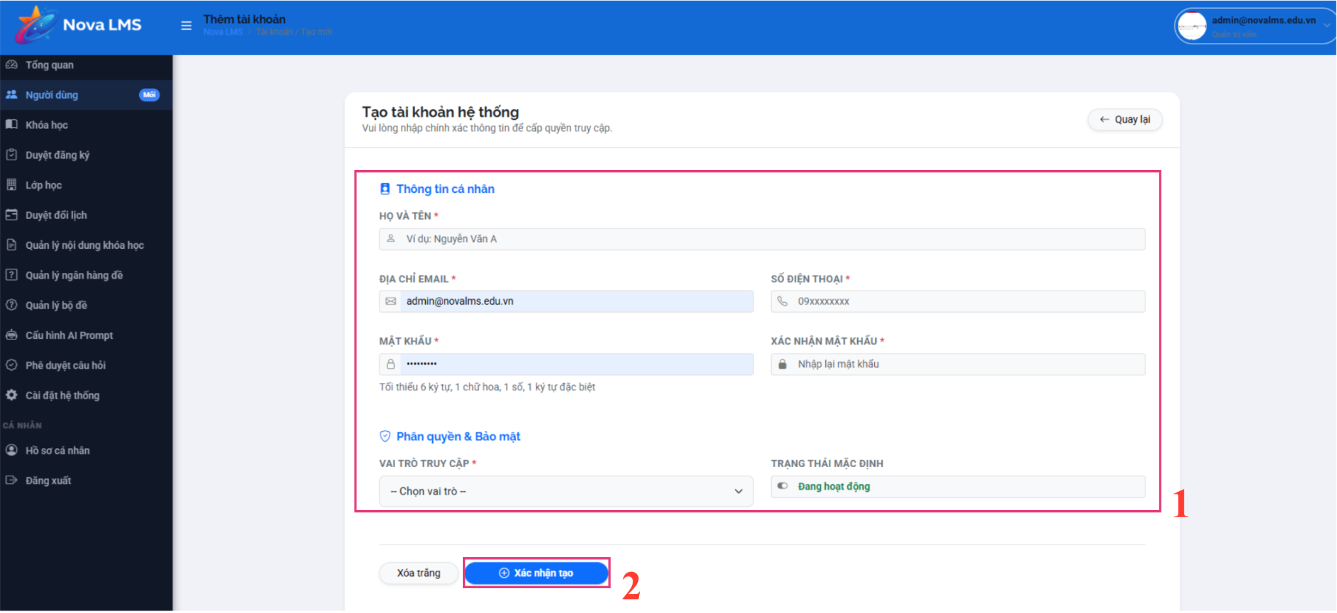
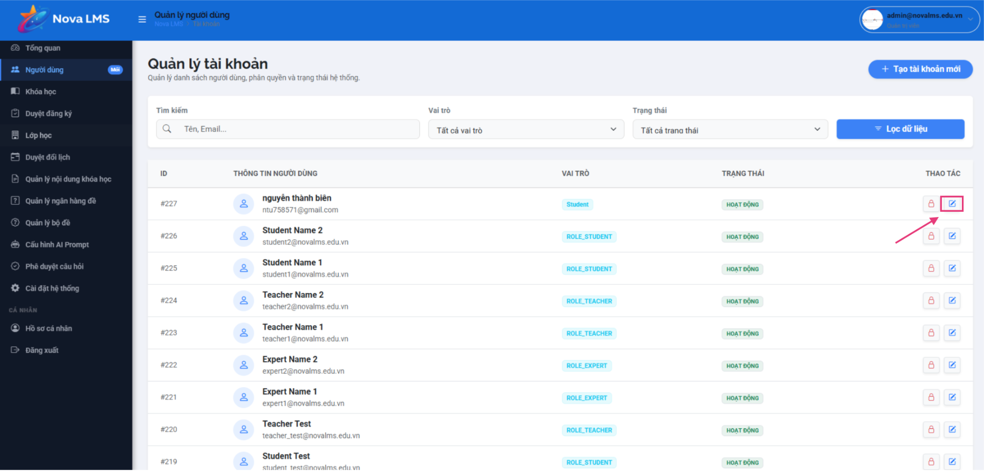
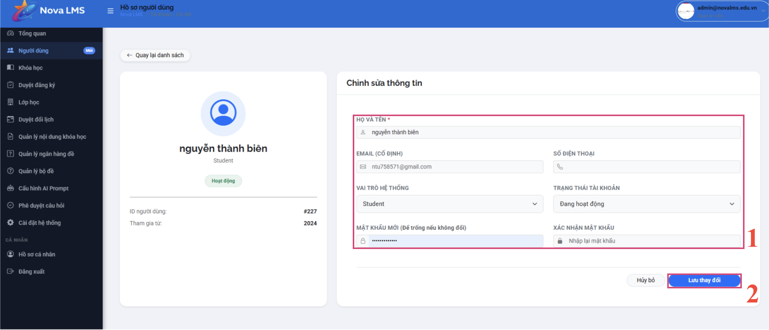
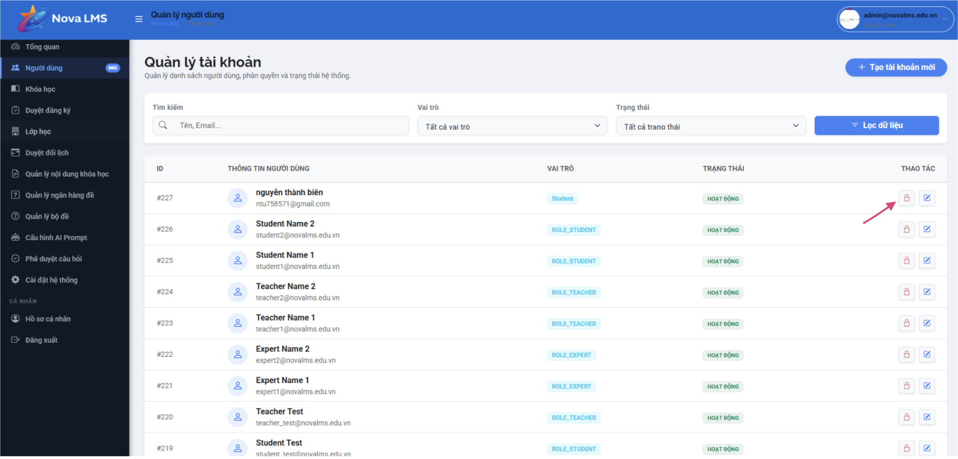
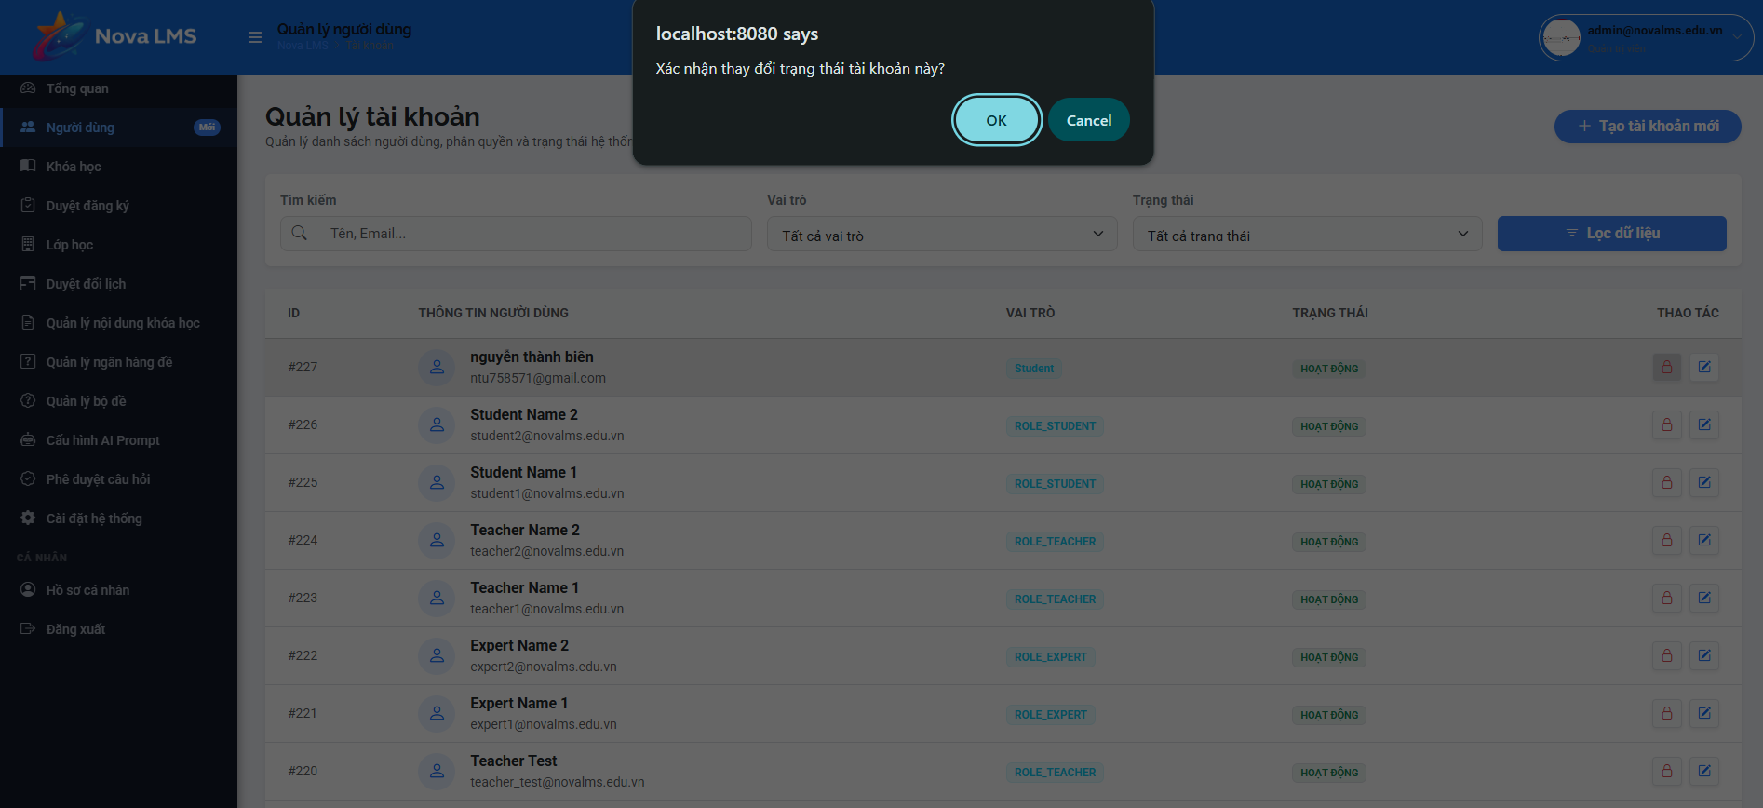
Step 1: Go to Users from the sidebar.
Step 2: View the full list of system users. Filter or search by:
- Name / Email
- Role: Admin, Manager, Expert, Teacher, Student
- Status: Active, Draft, Paused
Step 3: Create a new account:
- Click 'Add User'.
- Fill in: Full Name, Email, Role, Status, Gender.
- Click 'Save'.
Step 4: View account details by clicking 'View Details' on a user card.
Step 5: Edit an account:
- Click 'Edit'.
- Modify any account information.
- Click 'Save Changes'.
Step 6: Deactivate or reactivate an account:
- Click 'Deactivate' to disable the account — users will not be able to log in.
- Click 'Reactivate' to re-enable the account.

3.6.2 Course Management
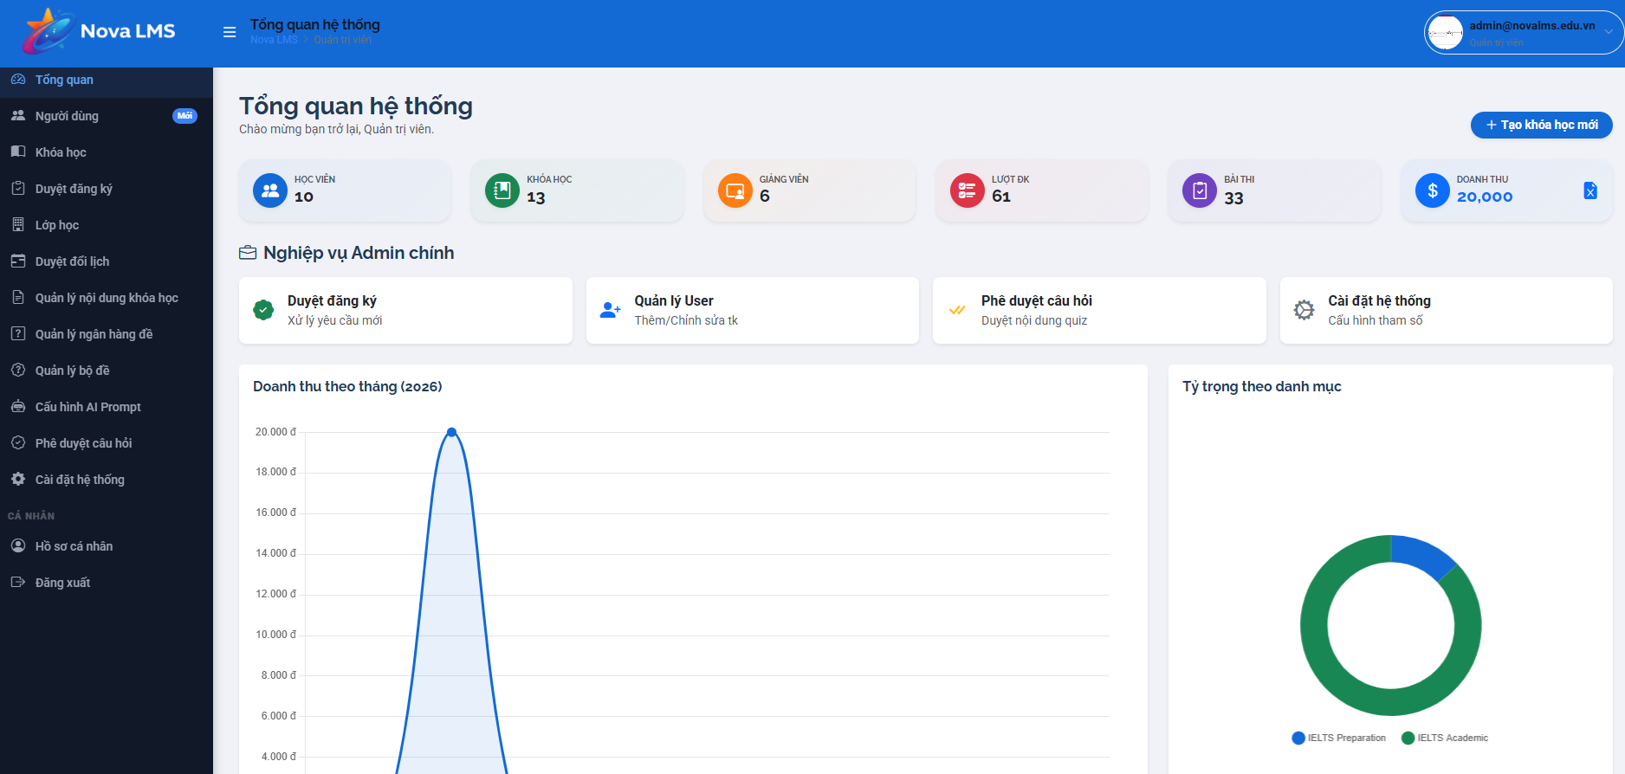
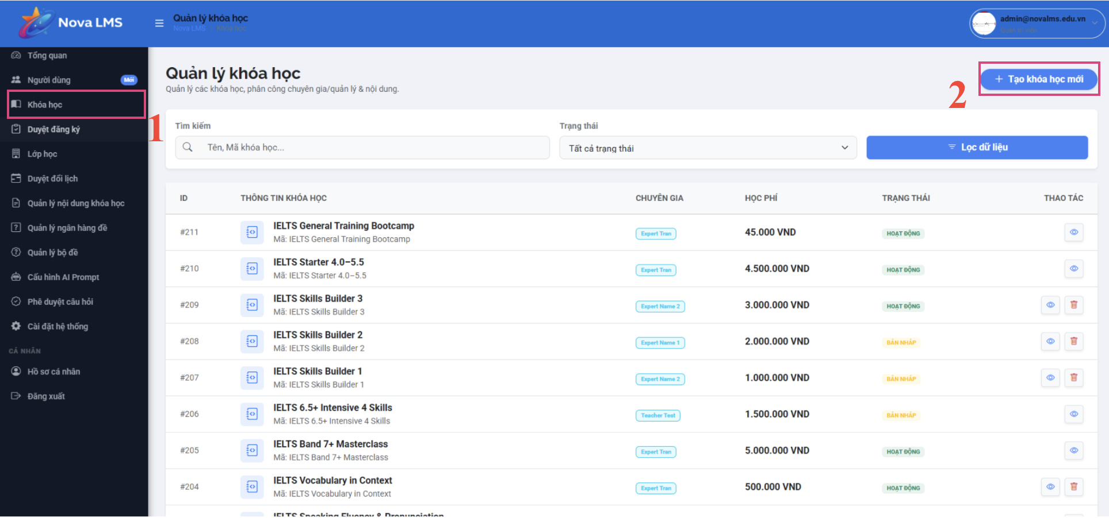
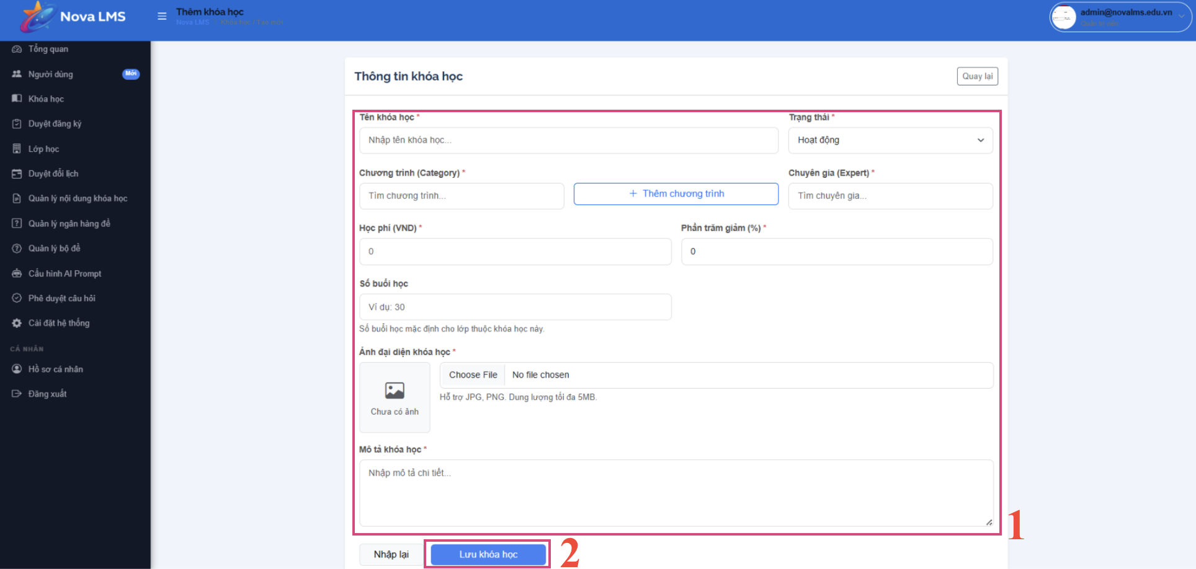
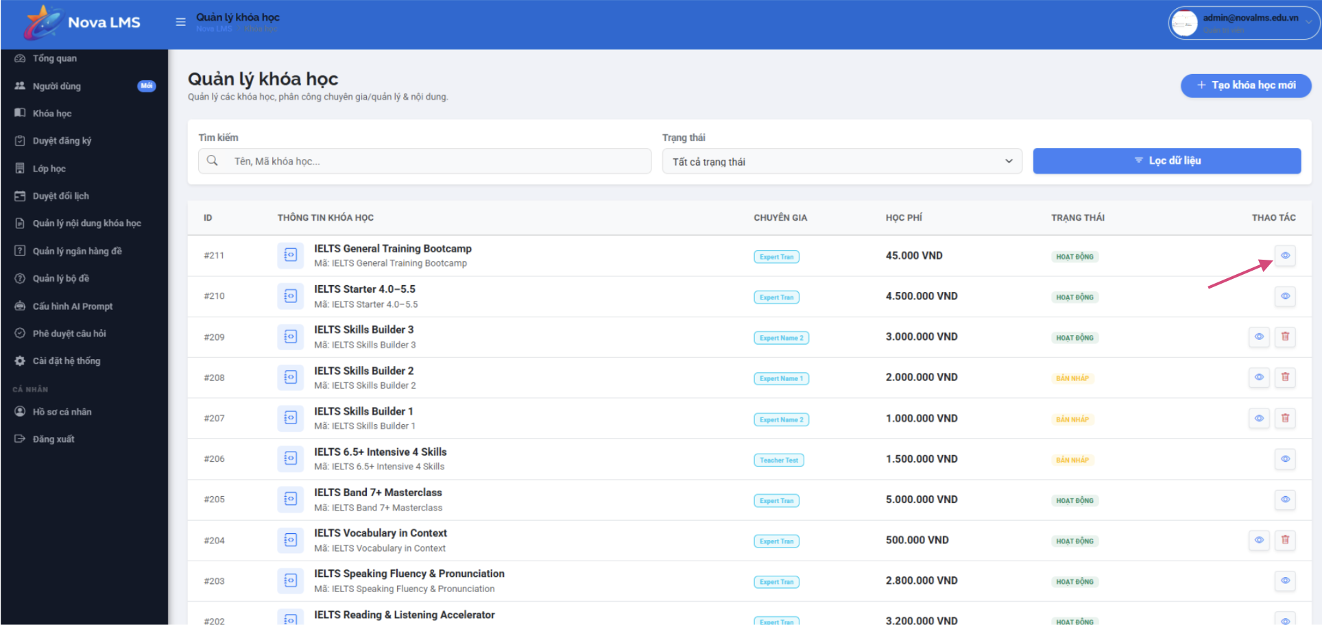
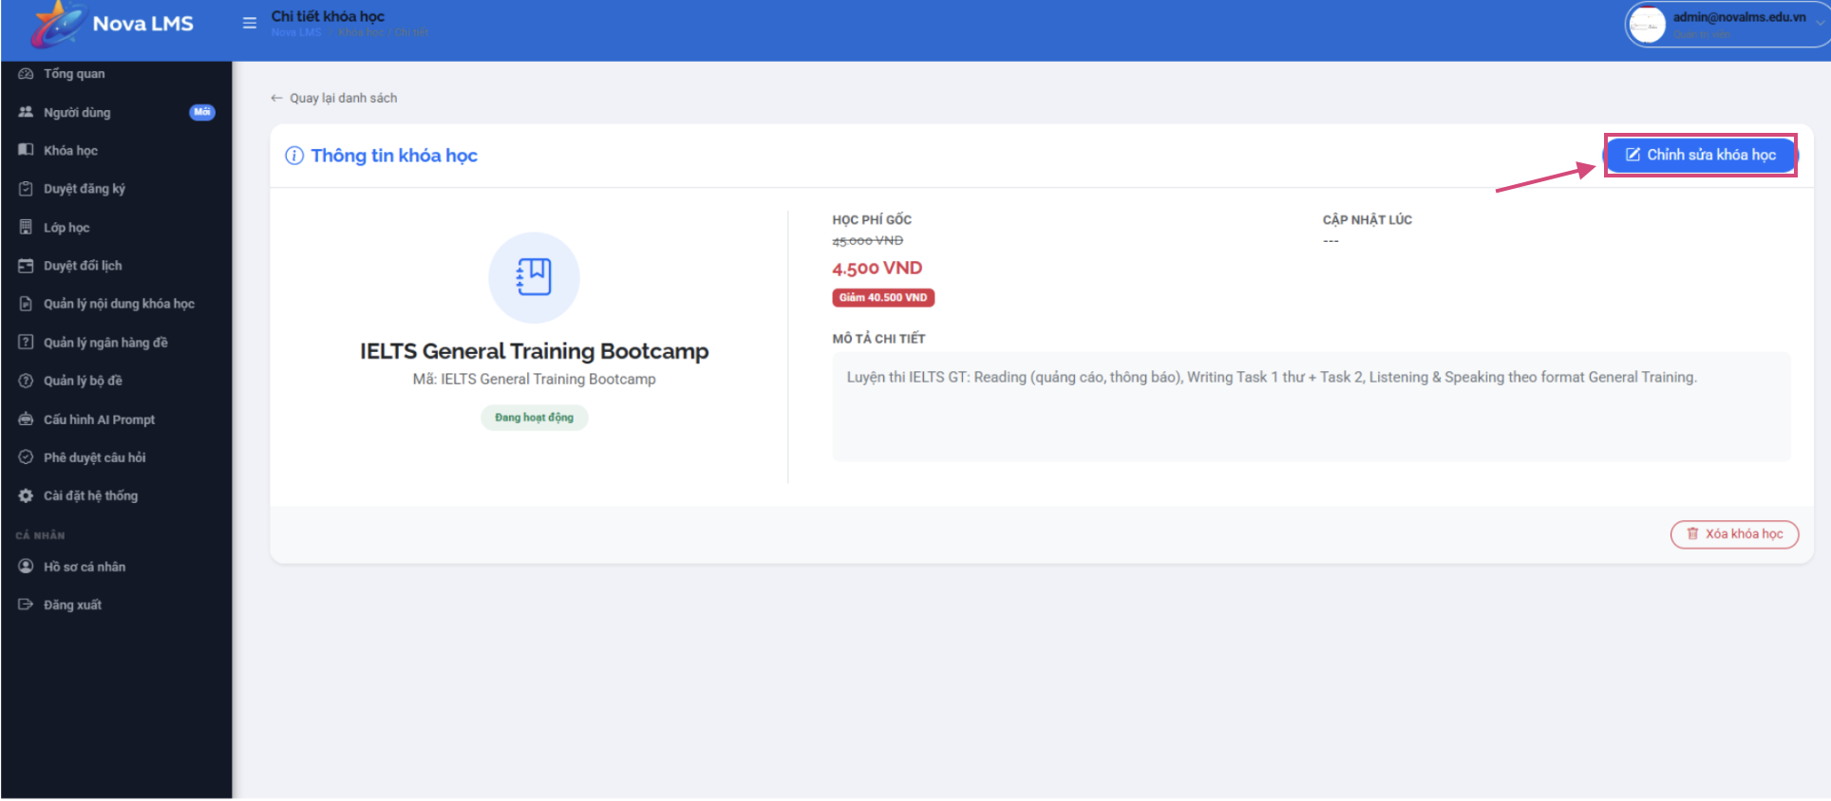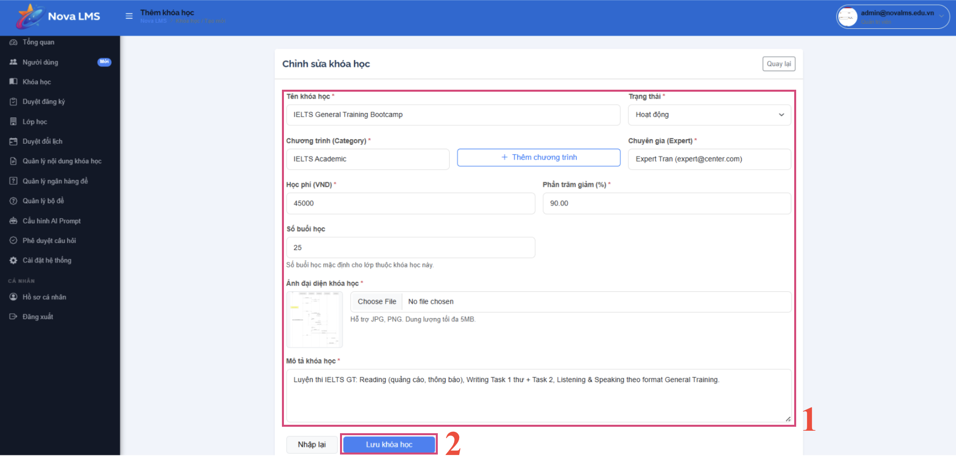
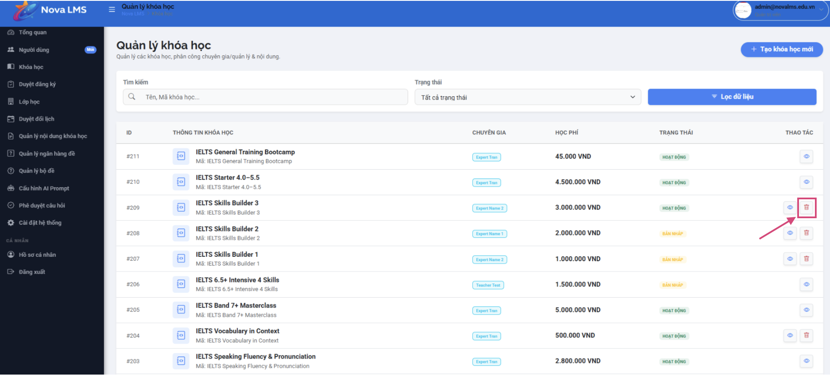
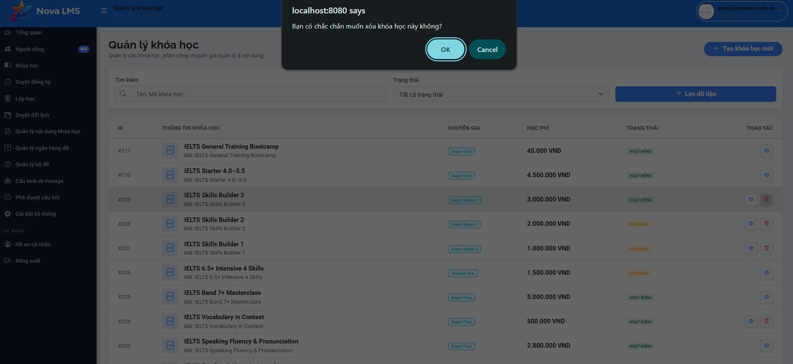
Step 1: Go to Courses from the sidebar.
Step 2: View the list of all courses. Filter or search by:
- Course Name
- Status: Active, Draft, Inactive
Step 3: Create a new course:
- Click 'Add Course'.
- Fill in: Course Name, Category, Expert, Price, Sale %, Course Avatar, Description.
- Click 'Save Course'.
Step 4: View course details by clicking 'View Details' on a course card.
Step 5: Edit a course:
- Click 'Edit Course' from the course detail page.
- Modify any course information.
- Click 'Save Changes'.
Step 6: Delete a course:
- Click 'Delete Course' on the course detail page.
- Confirm deletion. Note: courses with active registrations cannot be deleted.

3.6.3 Setting
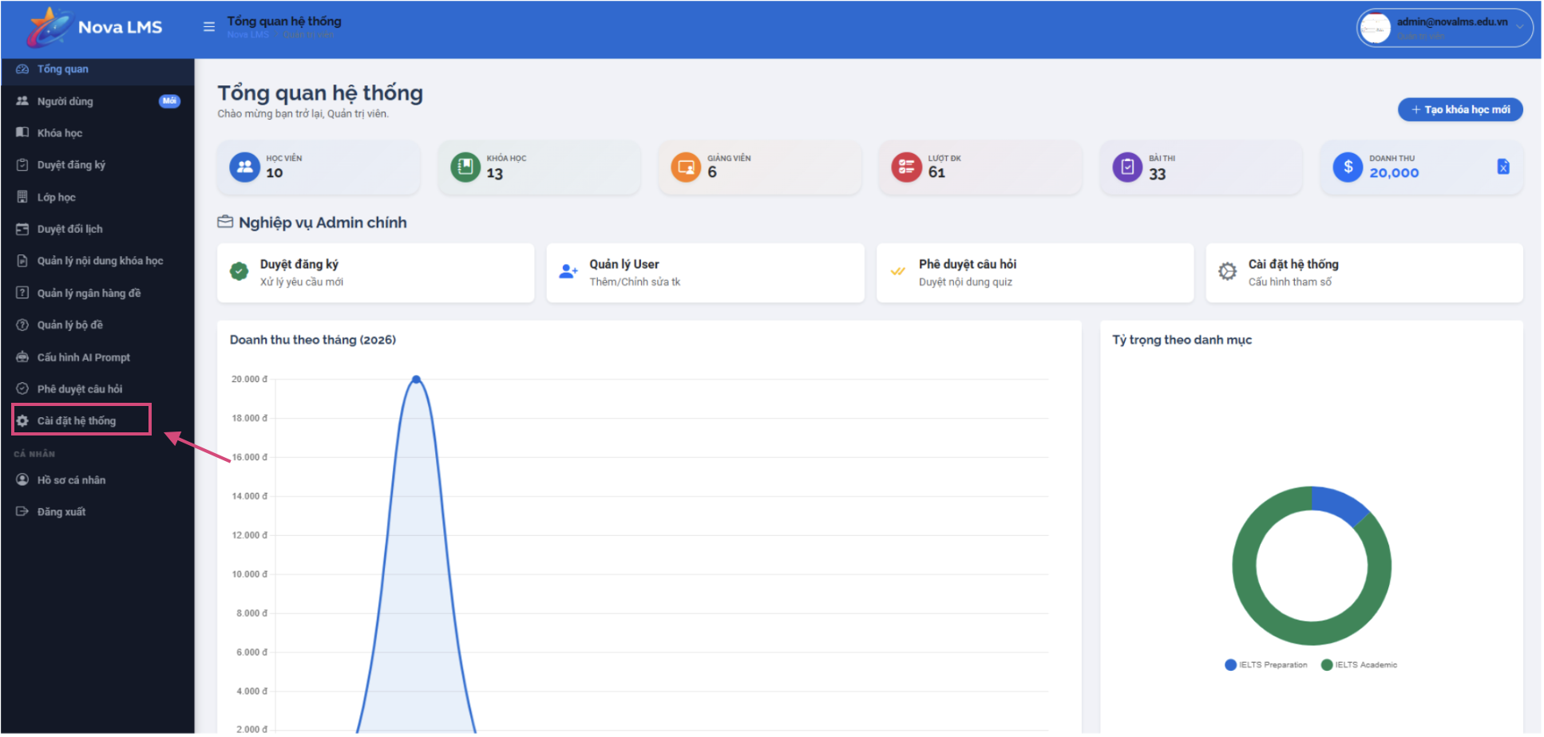
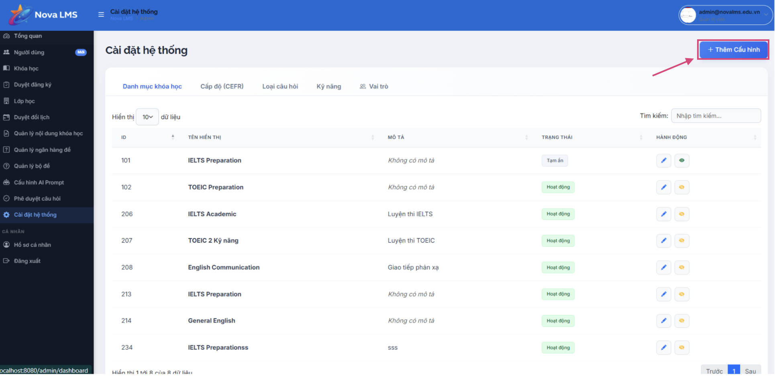
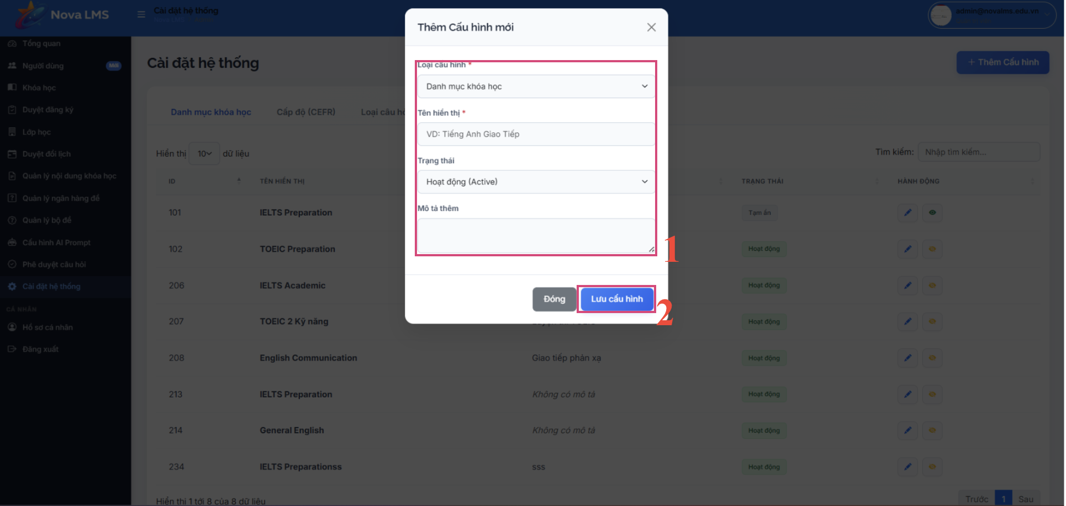
Step 1: Go to System Settings from the sidebar.
Step 2: Manage system-wide configurations:
- Course Categories:
- View all course categories (e.g., IELTS, TOEIC, GENERAL).
- Click 'Add Category' to create a new category.
- Fill in: Category Name, Value — format: UPPERCASE_WITH_UNDERSCORES.
- Click 'Save'.

3.7 Manager

3.7.1 Class Management
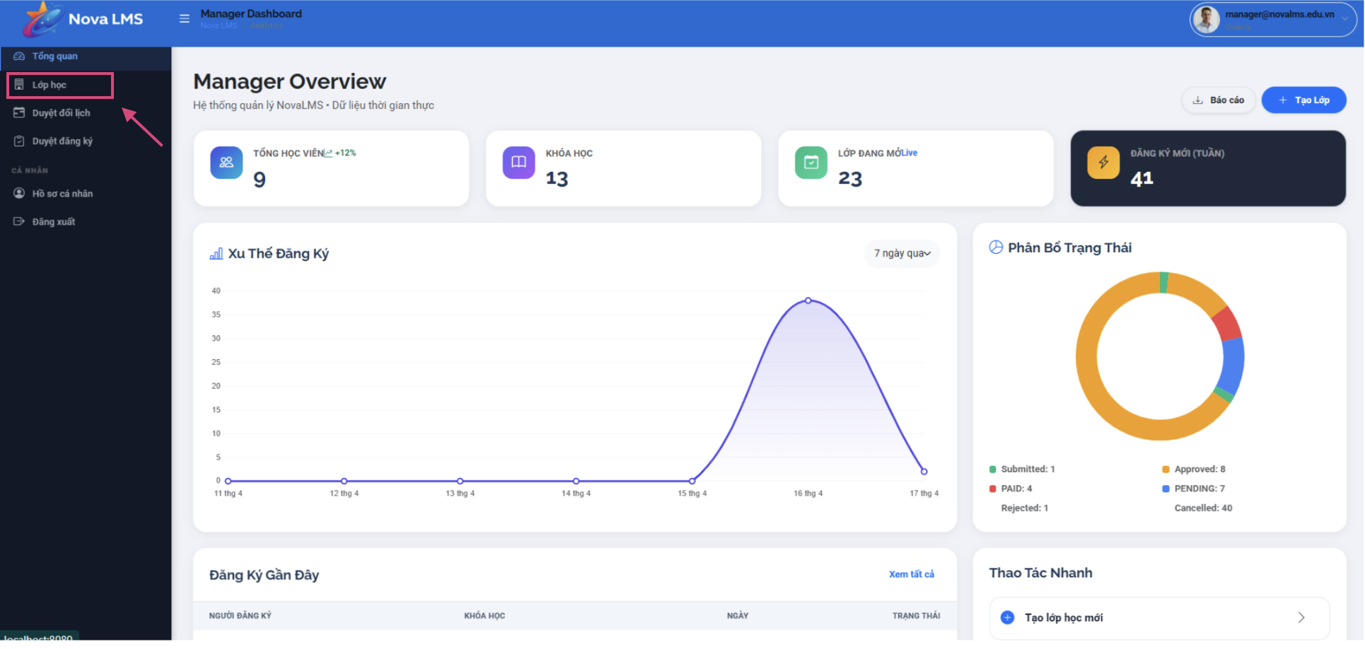
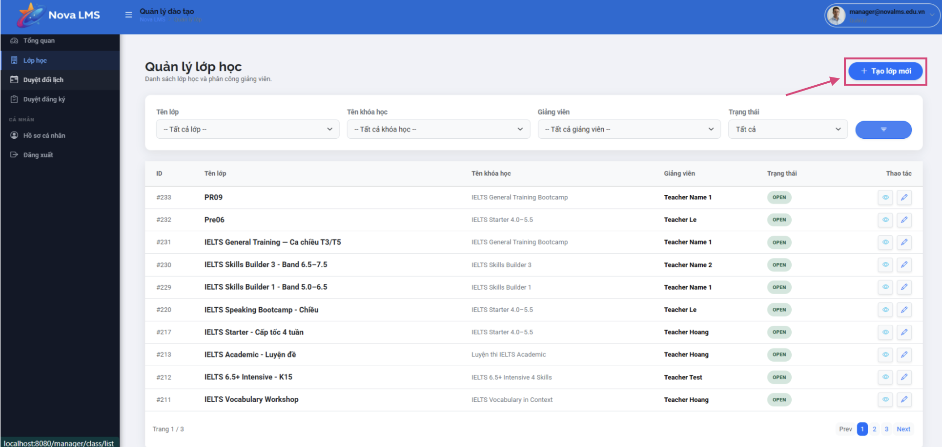
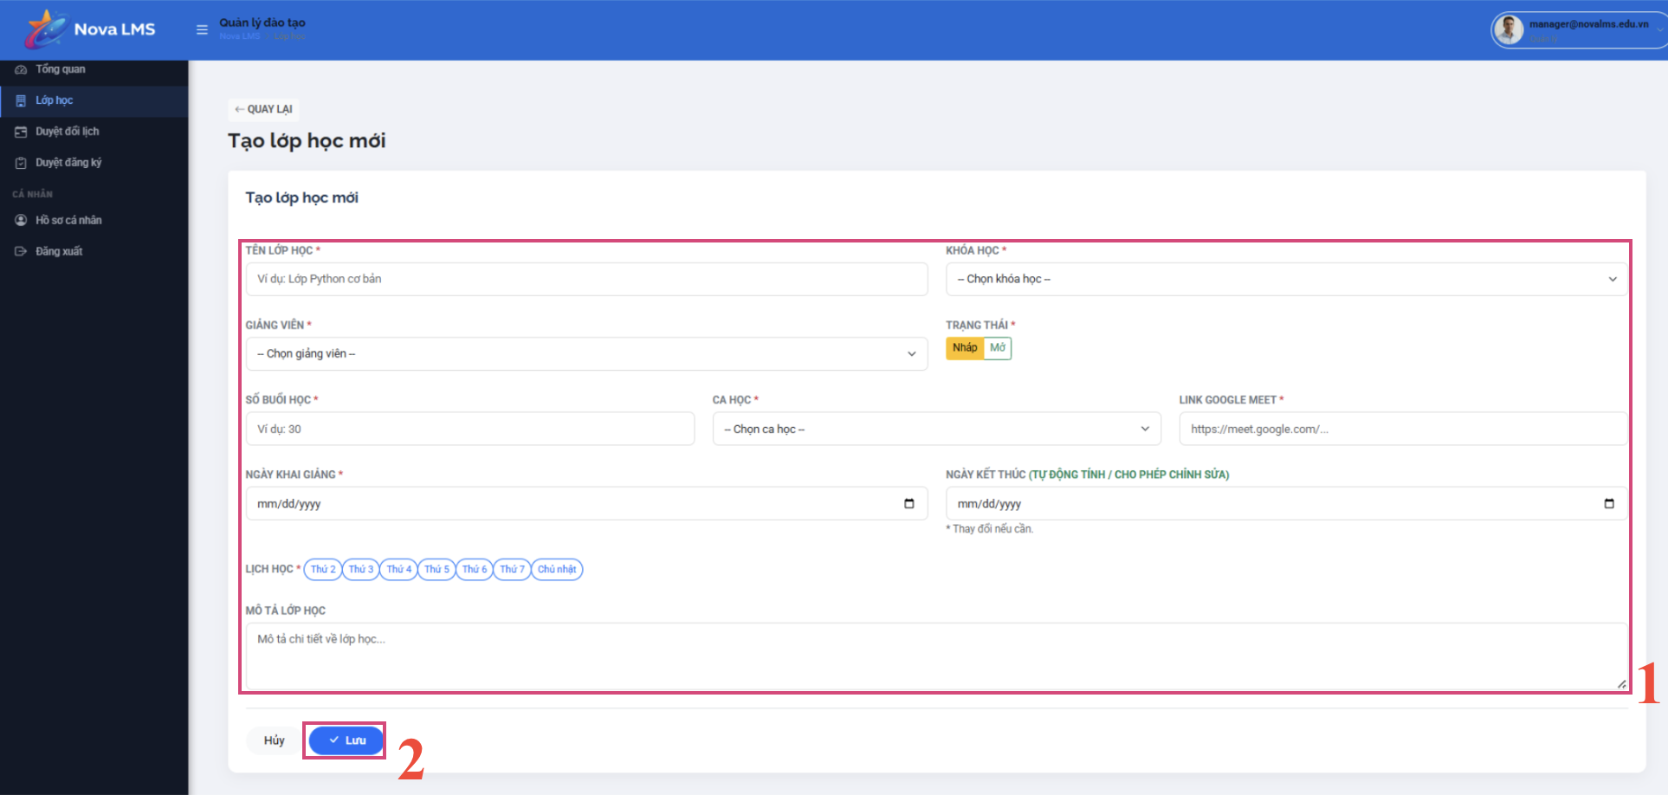
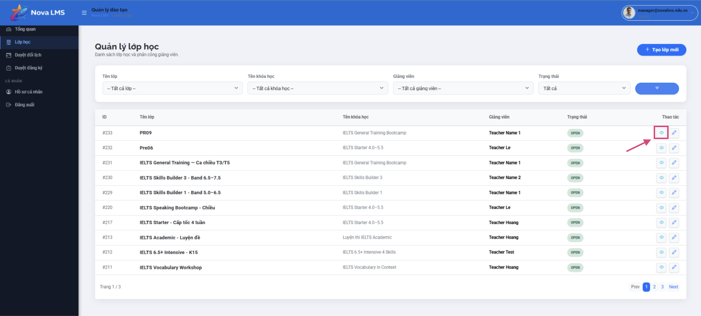
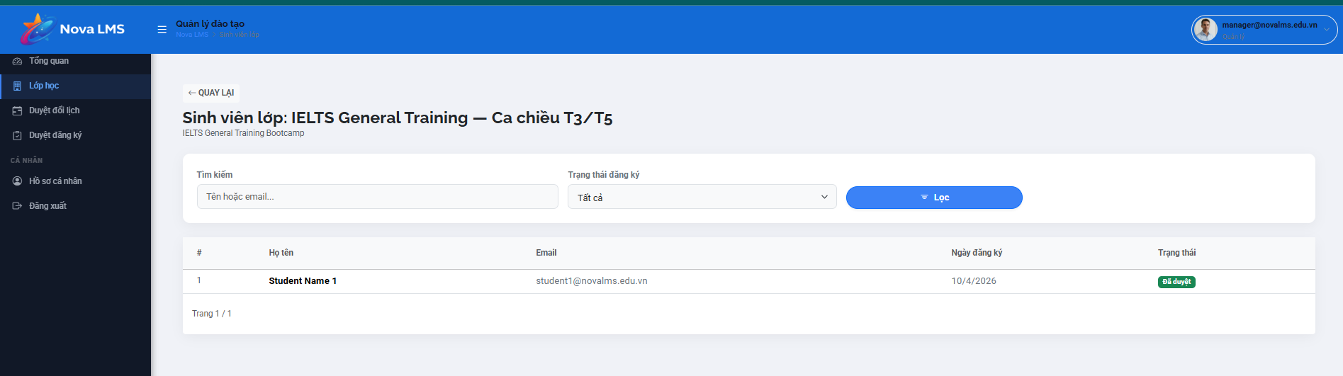
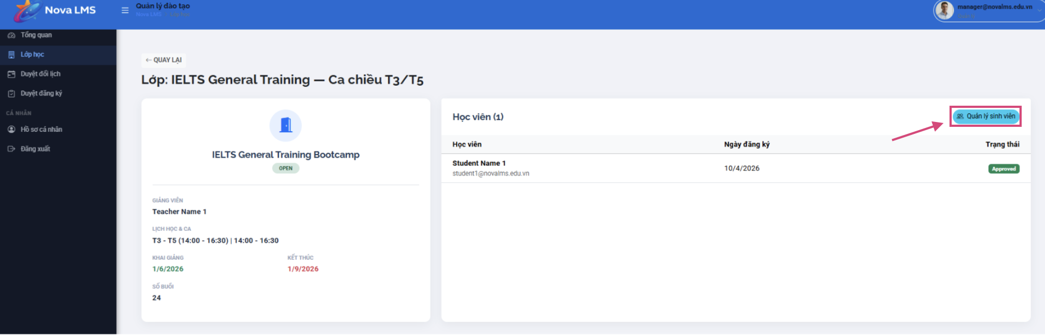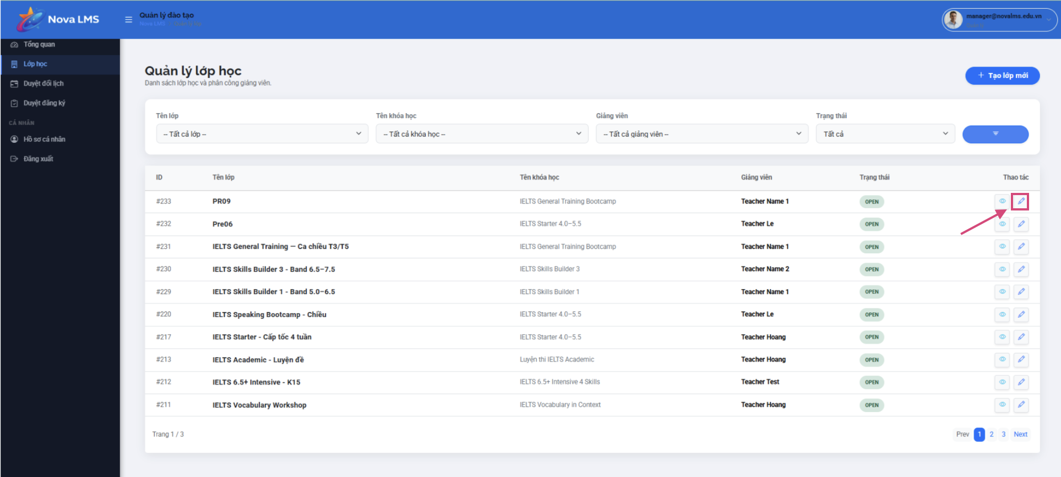
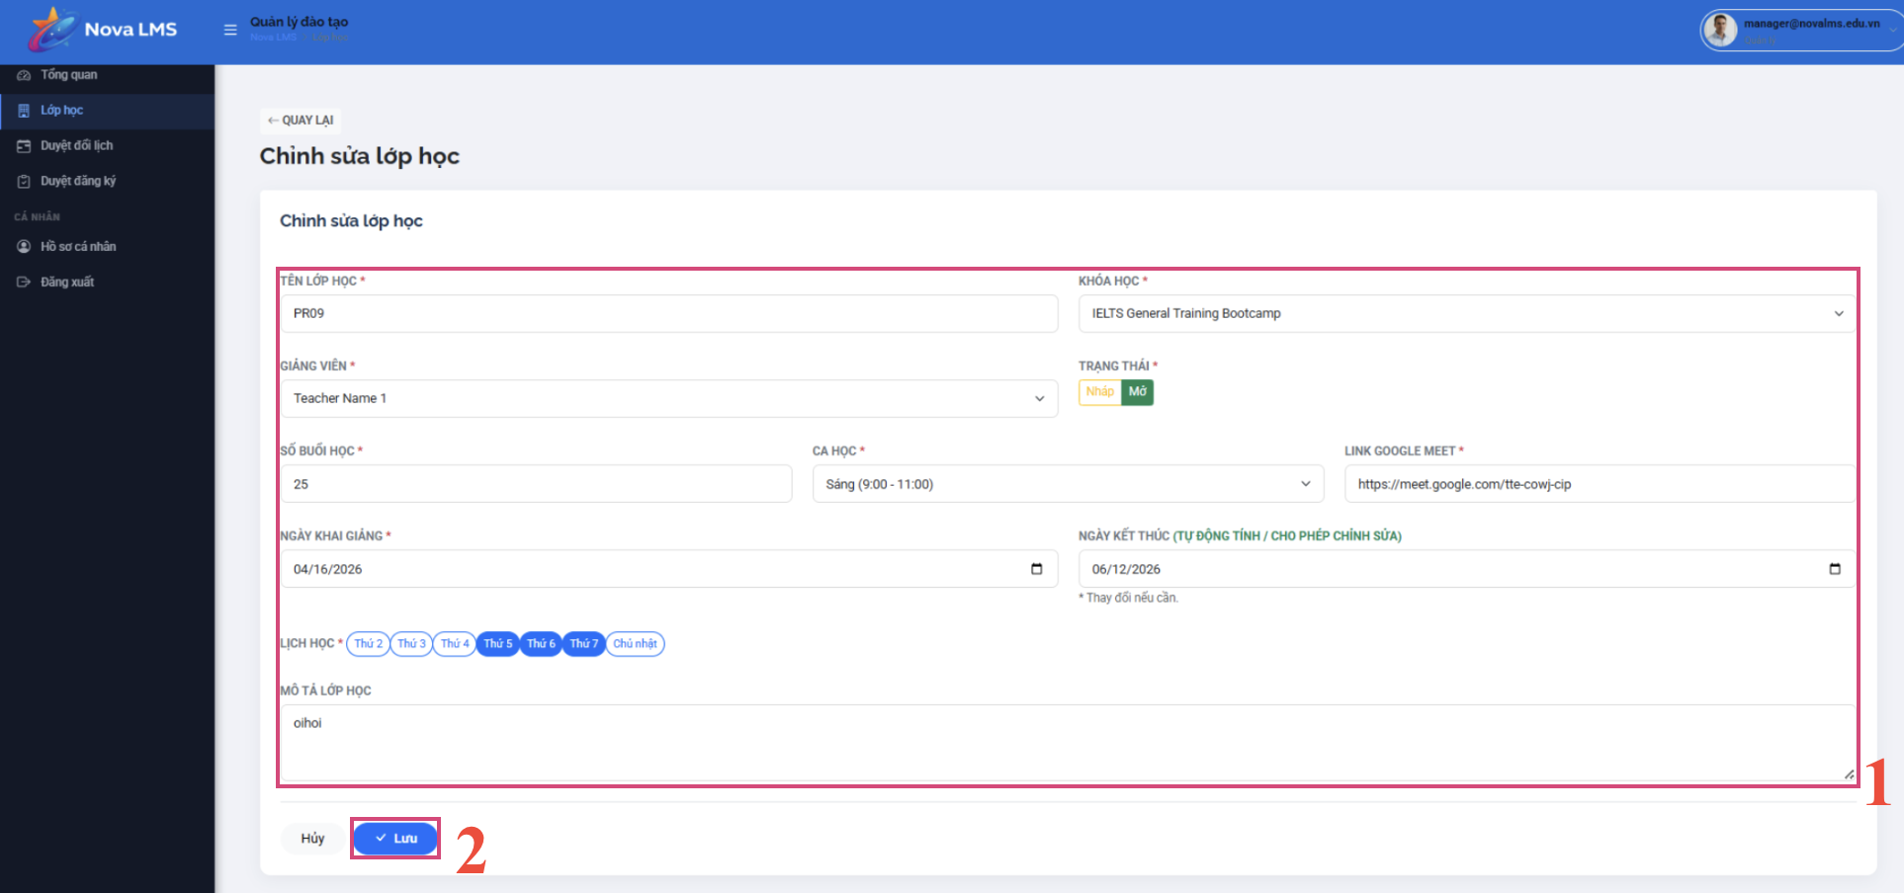
Step 1: Go to Classes from the sidebar.
Step 2: View all classes. Filter or search by:
- Class Name
- Status: Active, Ended
Step 3: Create a new class:
- Click 'Add Class'.
- Fill in: Class Name, Select Course, Select Teacher, Number of Sessions.
- Click 'Save'.
- The assigned teacher will receive an email notification.
Step 4: View class details:
- Click 'View Details' on a class card.
- View enrolled students, assigned teacher, and schedule.
Step 5: Manage students in a class:
- Click 'Manage Students' from the class detail page.
- View the list of enrolled students.
- You can remove a student from the class if needed.
Step 6: Edit or end a class:
- Click 'Edit' to modify class details.
- Click 'End Class' to close the class when all sessions are completed.

